
Tribhuvan University
Faculty of Humanities and Social Science
A Project Report On
“AI Text Detector”
In partial fulfillment of requirements in Bachelor in Computer Applications
Submitted by:
Saurav Munikar (6-2-410-139-2021)

July, 2026 A.D.
Under the Supervision of
Mr. Niraj Khadka


Tribhuvan University
Faculty of Humanities and Social Science
A Project Report On
“AI Text Detector”
In partial fulfillment of requirements in Bachelor in Computer Applications
Submitted by:
Saurav Munikar (6-2-410-139-2021)

July, 2026 A.D.
Under the Supervision of
Mr. Niraj Khadka


Tribhuvan University
Faculty of Humanities and Social Science

SUPERVISORS RECOMMENDATION
It is my pleasure to recommend that a project report on “AI Text Detector” has been prepared under my supervision by Saurav Munikar in partial fulfillment of the requirement of the degree of Bachelor of Computer Applications. His report is satisfactory and is an original work done by him to process for the future evaluation.

Mr. Niraj Khadka
SUPERVISOR
Lecturer, Department of IT
Prime College


Tribhuvan University
Faculty of Humanities and Social Science

LETTER OF APPROVAL
This is to certify that this project report prepared by Saurav Munikar on “AI Text Detector” in partial fulfillment of the requirements for the degree of Bachelor in Computer Application has been evaluated. In our opinion it is satisfactory in the scope and quality as a project for the required degree.
Mr. Niraj Khadka  Supervisor  Prime College  Khusibu, Nayabajar, Kathmandu | Ms. Rolisha Sthapit  Program Co Ordinator/ Internal  Examiner  BCA Department  Prime College  Khusibu, Nayabajar, Kathmandu
Mr.
External Examiner

ACKNOWLEDGEMENT
This project on developing an AI Text Detector, which detects machine generated text using statistical NLP, K Nearest Neighbors (KNN), and Cosine Similarity, could not have been achieved without the kind support of many individuals. I am grateful to Mr. Niraj Khadka, Project Supervisor and Coordinator, for his guidance, valuable suggestions, and steady encouragement throughout the development of this project. His knowledge of the subject, along with his encouragement, helped learn the concepts of Natural Language Processing and machine learning deeply. I also thank my teachers, mentors, friends, and classmates for their suggestions during the testing phase, which helped improve the performance and functionality of the detector. I am also grateful to everyone who helped bring this project to completion, directly or indirectly.
Saurav Munikar

ABSTRACT
To evaluate adversarial evasion techniques (e.g. synonym swapping and spelling tweaks), the project implements robust offline data augmentation workflows using the nlpaug Python library, which allows calibrating the grammar perfection discount factor under synthetic typo loads. The user interface features a prominent Classification Verdict banner at the top of the dashboard indicating if text is most probably written by AI, mixed, or human.
The individual metrics are combined via a weighted ensemble (25% Logistic Regression, 25% Character Trigram Similarity, 20% KNN Classifier, 15% POS Syntax Ratios, 10% Cosine Similarity, and 5% Perplexity) to calculate an overall AI probability. The application features an interactive single page dashboard built using HTML5 custom CSS variables and Vanilla JavaScript. It incorporates PDF.js and Mammoth.js for client side document parsing, SVG based clean minimalist visualization charts, an interactive sentence level perplexity heatmap, a prominent classification verdict banner, and a mathematical resolution panel powered by MathJax to trace raw formulas in real time. The system further integrates a secure User Authentication module supporting dual login credentials (username or email), a Dual-Engine Persistent Database Architecture combining a server-side SQLite3 database with client-side IndexedDB browser storage for offline fallback, and a Guest Daily Analysis Quota system limiting unauthenticated users to one free analysis per day while granting registered users unlimited access.
Keywords: Logistic Regression, data augmentation workflows, Character Trigram Similarity, KNN Classification, KNN Classifier, POS Syntax Ratios, Cosine Similarity, Perplexity, document parsing

Table of Contents
SUPERVISORS RECOMMENDATION iii
LETTER OF APPROVAL iv
ACKNOWLEDGEMENT v
ABSTRACT vi
LIST OF ABBREVIATIONS x
LIST OF FIGURES xi
LIST OF TABLES xiii
CHAPTER 1 INTRODUCTION 1
1.1. Introduction 1
1.2. Problem Statement 1
1.3. Objectives 2
1.4. Development Methodology 2
1.5. Report Organization 3
CHAPTER 2 BACKGROUND STUDY AND LITERATURE REVIEW 5
2.1. Background Study 5
2.2 Literature Review 6
CHAPTER 3 SYSTEM ANALYSIS AND DESIGN 9
3.1. System Analysis 9
3.1.1 Requirement Analysis 9
3.1.2. Feasibility Analysis 11
3.1.3. Object Modeling using Class Diagram 14
3.1.4. Dynamic Modelling using State and Sequence Diagrams 15
3.1.5. Process Modelling Using Activity Diagrams 18
3.2. System Design 20
3.2.1. Component Diagram 20
3.2.2. Deployment Diagram 21
3.3. Algorithm Details 21
3.3.1. Statistical NLP Algorithm (Perplexity & Burstiness) 21
3.3.2. KNN Classifier 22
3.3.3. Cosine Similarity (Vector Space Model) 23
3.3.4. Stylometric Logistic Regression Classifier 23
3.3.5. Character Trigram Cosine Similarity 24
3.3.6. POS Syntax Ratio Cosine Similarity 24
3.3.7. Heuristic Grammar & Typography Analyzer 24
3.3.8. Ensemble Scoring & Grammar Calibration 25
CHAPTER 4 IMPLEMENTATION AND TESTING 26
4.1. Implementation 26
4.1.1. Tools Used 26
4.1.2. Module Implementation Details 26
4.1.2.1. FileParser Module 26
4.1.2.2. Perplexity & Burstiness Module 27
4.1.2.3. KNN Heuristic Feature Module 28
4.1.2.4. KNN Voting Classifier Module 28
4.1.2.5. Cosine Similarity Feature Module 28
4.1.2.6. Cosine Similarity Angle Module 29
4.1.2.7. Logistic Regression Classifier Module 29
4.1.2.8. Character Trigrams Classifier Module 30
4.1.2.9. POS Syntax Ratios Classifier Module 30
4.1.2.10. ChartRenderer Gauge Module 31
4.1.2.11. ChartRenderer Scatter Plot Module 31
4.1.2.12. ChartRenderer Radar Chart Module 32
4.1.2.13. app.js Analysis Controller Module 32
4.1.2.14. app.js UI Event Listener Module 33
4.1.2.15. style.css Custom Visual Styles 33
4.1.2.16. HTML5 Dashboard Layout Structure 34
4.1.2.17. Heuristic Grammar & Typography Module 34
4.2. Testing 35
4.2.1. Test Case for Unit Testing 35
4.2.2. Dataset Training & Evasion Robustness Testing 39
4.3. Result Analysis 40
4.3.1. AI Probability Classification Analysis 40
4.3.2. Classifier Performance Analysis 42
4.3.3. AI Probability Distribution Analysis 43
4.3.4. Detector Accuracy Evaluation 45
4.3.5. Detailed Sample Text Algorithmic Calculation Analysis 48
CHAPTER 5 CONCLUSION AND FUTURE RECOMMENDATIONS 52
5.1. Conclusion 52
5.2. Future Recommendations 53
REFERENCES 54
APPENDICES 1

LIST OF ABBREVIATIONS
API | Application Programming Interface (External Endpoint)
CDN | Content Delivery Network
CLI | Coleman Liau Readability Index
CSS | Cascading Style Sheets
DOM | Document Object Model
GPT | Generative Pre-trained Transformer
HTML | HyperText Markup Language
KNN | K-Nearest Neighbors (Instance-Based Classifier)
LLM | Large Language Model (ChatGPT, Claude, Gemini)
NLP | Natural Language Processing
PDF | Portable Document Format
POS | Part-of-Speech (Grammatical Category Ratios)
SVG | Scalable Vector Graphics (Visualization Charts)
TTR | Type-Token Ratio (Lexical Diversity)
VSM | Vector Space Model (Cosine Similarity)

LIST OF FIGURES
Figure 1.1: | Agile Methodology........................................................................... | 3
Figure 3.1: | Use Case Diagram for AI Text Detector....................................................... | 9
Figure 3.2: | Gantt Chart for AI Text Detector............................................................ | 14
Figure 3.3: | Class Diagram for AI Text Detector.......................................................... | 15
Figure 3.4: | State Diagram for AI Text Detector.......................................................... | 16
Figure 3.5: | Sequence Diagram for AI Text Detector....................................................... | 17
Figure 3.6: | Activity Diagram for AI Text Detector....................................................... | 19
Figure 3.7: | Component Diagram for AI Text Detector...................................................... | 20
Figure 3.8: | Deployment Diagram for AI Text Detector..................................................... | 21
Figure 4.1: | Code Snippet of FileParser Module........................................................... | 26
Figure 4.2: | Code Snippet of Perplexity & Burstiness Module.............................................. | 27
Figure 4.3: | Code Snippet of KNN Feature Module.......................................................... | 27
Figure 4.4: | Code Snippet of KNN Classifier Module....................................................... | 28
Figure 4.5: | Code Snippet of Cosine Similarity Feature Module............................................ | 29
Figure 4.6: | Code Snippet of Cosine Similarity Angle Module.............................................. | 30
Figure 4.7: | Code Snippet of Logistic Regression Module.................................................. | 31
Figure 4.8: | Code Snippet of Character Trigram Module.................................................... | 31
Figure 4.9: | Code Snippet of POS Syntax Ratio Module..................................................... | 32
Figure 4.10: | Code Snippet of ChartRenderer Gauge Module.................................................. | 32
Figure 4.11: | Code Snippet of ChartRenderer Scatter Plot Module........................................... | 33
Figure 4.12: | Code Snippet of ChartRenderer Radar Chart Module.......................................... | 34
Figure 4.13: | Code Snippet of app.js Analysis Controller Module........................................... | 34
Figure 4.14: | Code Snippet of app.js UI Event Listener Module............................................. | 35
Figure 4.15: | Code Snippet of style.css Custom Visual Styles.............................................. | 35
Figure 4.16: | Code Snippet of HTML5 Dashboard Layout Structure....................................... | 36
Figure 4.17: | Code Snippet of Heuristic Grammar & Typography Module................................ | 37
Figure 4.18: | AI Probability Score Distribution......................................................................... | 39
Figure 4.19: | Classifier Performance Analysis.......................................................................... | 40
Figure 4.20: | AI Probability Trend by Document Category........................................................ | 41
Figure 4.21: | Confusion Matrix data from code........................................................................ | 42
Figure 4.22: | Confusion Matrix................................................................................................. | 43

LIST OF TABLES
Table 3.1: | Schedule Feasibility.............................................................................................. | 14
Table 4.1: | Test Cases for Unit Testing of Dashboard Interface and File Parsers..................... | 37
Table 4.2: | Test Cases for Verification of Classification Accuracy...................................... | 38
Table 4.3: | AI Probability Classification Analysis...................................................... | 39
Table 4.4: | Classifier Performance Analysis............................................................. | 40
Table 4.5: | AI Probability Distribution Analysis........................................................ | 41
Table 4.6: | Detector Classification Categories.......................................................... | 42

CHAPTER 1

INTRODUCTION

1.1. Introduction
Generative AI models like ChatGPT, Claude, and Gemini have changed how text is produced at scale. Their rapid adoption across industries has introduced serious challenges around content authenticity. While these systems increase writing efficiency, they present severe challenges across multiple sectors, including plagiarism in academic writing, automated fake news dissemination, and artificial content spamming on web search platforms.
Because AI generated text is grammatically correct and coherent, spotting it by eye is extremely difficult. Automated detection tools are therefore needed. Standard commercial detectors rely heavily on calling proprietary API endpoints, introducing privacy concerns and network latency.
This project addresses that gap with Sentinel AI Text Detector — a privacy-preserving tool that executes all stylometric feature extraction and machine learning classification directly inside the user's browser sandbox without sending document text to external cloud AI vendors. To enable persistent history tracking and secure user access without compromising privacy, the system integrates a Dual-Engine Persistent Database Architecture (a local SQLite3 server database backed by client-side browser IndexedDB fallback), accompanied by a secure User Authentication system and Guest Daily Quota Management.
The application is constructed using HTML5, CSS3, ES6 JavaScript, and a lightweight Python REST API server (server.py) backed by an SQLite3 database (sentinel.db). It leverages PDF.js and Mammoth.js to parse PDF and Word documents locally, SentinelDB (IndexedDB API) for local offline browser storage, and LocalStorage for user session and guest quota tracking. Users can create accounts using a username, email address, and password, authenticate seamlessly via dual login credentials (username or email), and securely search, manage, and inspect their personal analysis history database.

1.2. Problem Statement
The integration of generative language models into daily workflows has created significant security and integrity concerns:
- Students can generate complete essays and homework solutions, undermining learning evaluation standards.
- Automated bots generate large volumes of search engine optimized web text, degrading content quality online.
- Most commercial AI checkers require sending user documents to third-party cloud servers or external API endpoints, raising severe data privacy concerns for proprietary, confidential, or personal files.
- Existing detection tools act as black boxes, showing a single percentage score without explaining the mathematical or stylistic reasons behind it.

1.3. Objectives
The main objectives of this project are as follows:
- Design a single page web application that performs stylometric classification entirely in the browser.
- Code four independent engines using statistical NLP (Perplexity & Burstiness), instance based machine learning (KNN), Vector Space Models (Cosine Similarity), and Heuristic Grammar & Typography Analysis.
- Integrate client side libraries to parse text from .txt, .md, .docx, and .pdf files.
- Design animated SVG charts (gauge, scatter plot, and radar web) to illustrate document features visually.
- Provide a dedicated panel utilizing MathJax to show the exact calculations (Euclidean distance, standard deviation, cosine angles, and grammar penalties) behind the results.
Implement a secure User Authentication and Registration System allowing users to create accounts with a username, email address, and password, as well as supporting dual login credentials via username or email.
Develop a Dual-Engine Persistent Database Architecture combining a server-side SQLite3 database (sentinel.db) via REST API with a local browser IndexedDB (SentinelAIDB) fallback for offline operation.
Enforce a Guest Daily Analysis Quota and Data Security Boundaries limiting unauthenticated guests to 1 free analysis per calendar day while granting logged-in users unlimited analyses, isolating saved user history from guest access.

1.4. Development Methodology
The project was developed using the Agile methodology. Given the experimental nature of stylometric calculations and the need to adjust thresholds, an iterative development cycle allowed the team to refine modules progressively.
Sprint 1: Setup the project shell, custom CSS variables, and layout.
Sprint 2: Program the FileParser module, incorporating PDF.js and Mammoth.js.
Sprint 3: Build and tune the PerplexityAnalyzer and CosineSimilarityAnalyzer engines.
Sprint 4: Build the KNNClassifier and curate the local 5D reference dataset.
Sprint 5: Code the SVG ChartRenderer and integrate MathJax and the interactive sentence heatmap.
Sprint 6: Complete validation tests and finalize the documentation.

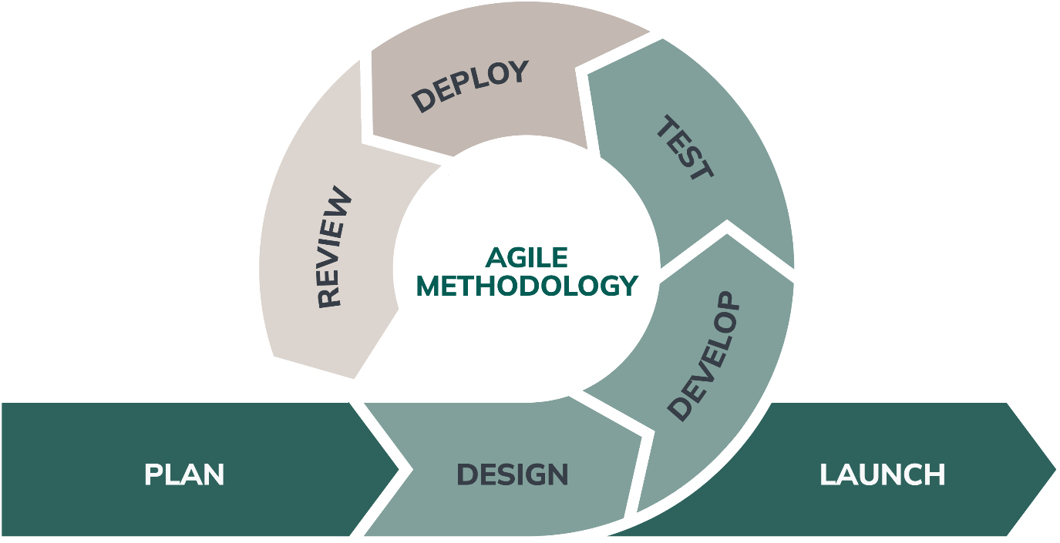

Figure 1.1: Agile Methodology

1.5. Report Organization
This report is organized into five chapters, each covering a specific stage of the project from initial research to final testing.
Below is a brief overview of each chapter:
Chapter 1 introduces the project. It explains why automated detection tools are needed, outlines the project objectives, and describes the core approach classifying text using linguistic markers like perplexity, burstiness, and lexical diversity.
Chapter 2 reviews the key research studies on stylometry and AI text detection. It covers methods like GLTR, DetectGPT, and lexical feature classifiers, and explains how this project builds on and extends those findings.
Chapter 3 covers system analysis and design. It documents the functional and non functional requirements, feasibility study, and architecture. UML diagrams including use case, class, sequence, state, and activity diagrams illustrate the interaction between the UI and the classification engines.
Chapter 4 covers the implementation. It describes each code module (FileParser, PerplexityAnalyzer, KNN, Cosine Similarity, Logistic Regression, Trigram, POS, Grammar, and ChartRenderer), the tools used, and the testing results with documented test cases.
Chapter 5 concludes the report. It summarizes what the project achieved, its accuracy results, and outlines recommended directions for future improvements such as WebAssembly model integration and multi lingual support.

CHAPTER 2

BACKGROUND STUDY AND LITERATURE REVIEW

2.1. Background Study
Stylometry the study of linguistic style rests on the premise that every writer possesses a unique, identifiable “writeprint.” This footprint manifests in average sentence length, punctuation usage, lexical choices, and structural complexity.
Large Language Models (LLMs), despite their fluency, do not write like humans. Because they generate text by predicting the next most likely word token, their output matches high probability patterns, resulting in low entropy (predictability) and highly uniform sentence lengths. Conversely, human writing exhibits “burstiness”a mix of short, simple sentences with long, complex structures and a richer vocabulary containing unique words used only once (Hapax Legomena).
Automating the capture of these differences requires extracting numeric vectors representing text attributes, which are then analyzed using statistical models, instance based classification, and geometry.
Statistical natural language processing provides a stable baseline for this analysis. By evaluating the perplexity of word sequences and the standard deviation of sentence lengths (burstiness), the system identifies the regular, predictable patterns typical of AI content.
To supplement statistical analysis, instance based machine learning is applied. A K Nearest Neighbors (KNN) classifier maps the document's syntactic features into a multi dimensional space, measuring Euclidean distance to a pre defined training set of human and AI documents to make a classification verdict.
Additionally, a Vector Space Model measures semantic alignments. By computing the cosine angle between the document's syntax vector and human/AI prototype vectors, it determines which category the text aligns with more closely.
Spelling and grammatical errors are also a meaningful feature in stylometric classification. Large Language Models are trained on curated, highly polished text datasets, meaning they output grammatically flawless prose. In contrast, human written text frequently exhibits minor typographical slips, incorrect spacing around punctuation, and occasional spelling and syntax agreement errors. Integrating a heuristic grammar and typography engine provides a robust discount modifier: the presence of minor errors lowers the text's grammar perfection score, which is used to calibrate the final AI probability, successfully reducing false positives on human essays.

2.2 Literature Review
The first significant advancement in automated text detection was introduced by Gehrmann et al. (2019) through the development of the Giant Language Model Test Room (GLTR). The authors demonstrated that generative language models produce text with extremely predictable token transitions. GLTR utilizes visual probability indicators to represent the likelihood of each word token falling within the top ranked vocabulary predictions of a target model. The study proved that machine generated content is overwhelmingly constructed using the top 10 to 100 most probable words under the model's probability distribution, whereas human writing consistently deviates from this trend, selecting unexpected or contextually creative words that lie outside these high probability thresholds. [1]
Addressing the need for zero shot text detection without retraining classifiers, Mitchell et al. (2023) developed DetectGPT, a novel zero shot detection method based on probability curvature. The researchers discovered that AI generated passages tend to lie in regions of negative curvature of the source model’s log probability function. By applying minor semantic perturbations (rewriting sentences slightly) and evaluating the difference in log likelihood, the authors proved that AI generated text exhibits a significant, consistent drop in log probability when perturbed. In contrast, human written text, which does not sit at the local maxima of an LLM's probability space, shows highly unpredictable and variable changes under the same perturbations. This discovery established a mathematical framework for zero shot classification using curvature. [2]
In the context of early transformer architectures, Solaiman et al. (2019) conducted a thorough evaluation of detection strategies on outputs from the GPT 2 model. Their research showed that combining simple lexical features such as the Type Token Ratio (TTR) and average word lengths with traditional TF IDF vector space classifiers yields remarkably high accuracy rates for early generation language models. This work proved that basic statistical markers and word frequencies carry sufficient stylistic information to differentiate human and machine text, establishing the foundational basis for lightweight, client side feature classification. [3]
As generative models evolved, Crothers et al. (2023) published a detailed systematic review in IEEE Access detailing the growing challenges and security vulnerabilities of existing detection methods. The authors analyzed the limitations of supervised neural network classifiers, highlighting their susceptibility to simple adversarial attacks, such as synonym swapping, character perturbation, and prompt manipulation. Additionally, their research revealed a systemic bias in statistical detectors, which frequently yield high false positive rates when evaluating the writing of non native English speakers. This study underscored the critical need for multi dimensional, hybrid detection approaches that do not rely solely on neural networks or singular probability scores. [4]
Adding a theoretical boundary to the discussion, Sadasivan et al. (2023) analyzed the fundamental limits of AI text detection at ICML. Their work proved that as generative models approximate the human text distribution more closely, the upper bound of detection accuracy decreases significantly. The study demonstrated that adversarial paraphrasing tools (such as Dipper) can easily bypass perplexity based and watermarked detection schemes by slightly altering word choices and sentene lengths. This research proved that singular classification models are highly vulnerable to evasion, necessitating ensemble systems that evaluate stylistic, syntactic, and structural markers concurrently. [5]
To resolve the sensitivity of vocabulary statistics to document length, Chakraborty et al. (2023) investigated the theoretical and practical boundaries of lexical features in AI text detection at NeurIPS. They analyzed how metrics like the Type Token Ratio (TTR) decrease naturally as text length increases due to repetitive functional vocabulary. The authors established that simple linear thresholds for lexical diversity lead to high false positive rates on longer human documents, proving the necessity of length adjusted normalization curves. Their findings validated that feature based stylometric classifiers must dynamically scale metrics (such as TTR and punctuation density) against document length to maintain detection accuracy and robustness.[6]

CHAPTER 3

SYSTEM ANALYSIS AND DESIGN

3.1. System Analysis

3.1.1 Requirement Analysis
3.1.1.1 Functional Requirements
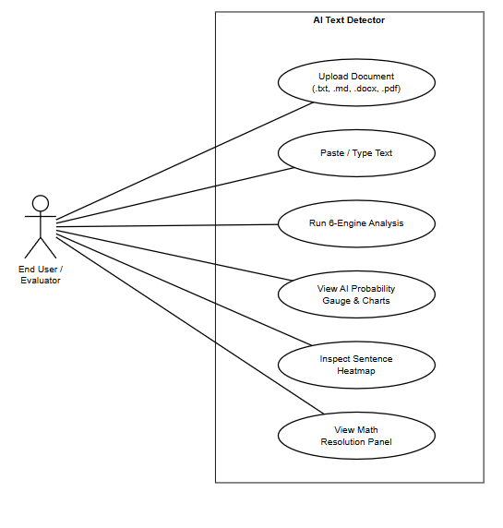
Figure 3.1: Use Case Diagram for AI Text Detector
a. Document or Text Input:
Users can paste raw text directly into a text area to analyze documents immediately.
b. File Drag and Drop:
Supports dragging and dropping .txt, .md, .pdf, and .docx files locally.

c. Overall Probability Gauge:
Displays a clean SVG gauge visualization representing the weighted ensemble probability of machine generation.
d. Word & Sentence Counting:
Shows the character and word counts of the text in real time.
e. Burstiness & Lexical Statistics:
Displays computed values for sentence length standard deviation (burstiness) and Type Token Ratio (TTR).
f. Sentence Perplexity Heatmap:
Color codes sentences based on their individual AI likelihood (AI Heavy, Mixed, Human like).
g. Sentence Inspector:
Clicking a heatmap sentence displays its word count, AI confidence, and classification.
h. User Authentication & Dual Registration System:
Supports user account creation with username, email address, and password. Enables dual login by username OR email address. Manages user sessions in localStorage and provides a confirmation popup modal on logout.
i. Dual-Engine Persistent Database Storage:
Automatically stores user accounts and analysis records in a backend SQLite3 database (sentinel.db) via a Python REST API server, with seamless client-side IndexedDB (SentinelAIDB) fallback for offline operation.
j. Guest Daily Analysis Quota & Dynamic Status Badge:
Enforces a daily limit of 1 free analysis for unauthenticated guests, while unlocking unlimited analyses upon logging in. Displays a real-time quota status badge in guest mode that automatically hides when logged in.
k. Analysis History Management & Real-Time Search:
Allows logged-in users to view, search, and delete saved analysis records. Supports multi-field real-time search (by title, body text snippet, verdict statement, and username) with icon-only action controls (View/Reload and Delete) and strict database user isolation (WHERE username = ?).
3.1.1.2. Non Functional Requirements
a. Usability (User Friendly):
The interface must remain clean and intuitive, requiring no technical styling training to operate.
b. Privacy (Data Security):
All AI classification and stylometric analysis computations execute entirely within the client browser sandbox. No user document text is transmitted to external third-party cloud AI services. The optional local SQLite3 backend server (localhost:5000) stores only user credentials and analysis metadata on the user's own machine, preserving full data sovereignty.
c. Low Latency Performance:
The document processing and classification pipeline must execute in less than 500 milliseconds.

d. Classification Accuracy:
The ensemble algorithms must be tuned to minimize false positives on human text and false negatives on AI content.
e. Reliability and Stability:
The browser environment must remain stable, running files up to 20,000 words without freezing the UI.
f. Portability:
The core AI detection engine runs as static files in any modern web browser. An optional lightweight Python REST API server (server.py) provides persistent SQLite3 database storage and user authentication, but the application gracefully falls back to browser IndexedDB storage when the server is offline, ensuring full portability.

3.1.2. Feasibility Analysis

3.1.2.1. Technical Feasibility
The system's technical feasibility is demonstrated by combining client-side web technologies with NLP algorithms and a lightweight backend server. It uses HTML5, CSS3, and ES6 JavaScript for the frontend, and Python's built-in http.server and sqlite3 modules for the backend REST API. By using PDF.js and Mammoth.js via CDNs, it parses uploaded documents without requiring external dependencies. The IndexedDB API provides seamless offline database fallback when the backend server is unavailable.

3.1.2.2. Operational Feasibility
The application is straightforward to use. Pasting text or dropping a document triggers charts, statistics, and a heatmap with no configuration required. Users can click highlighted sentences to inspect metrics, making it easy to understand the classification reasons.

3.1.2.3. Economic Feasibility
Economically, the project relies entirely on open source libraries, avoiding software licenses or subscription fees. Since execution happens entirely in the user's browser, there are no hosting costs or database storage requirements, resulting in zero server maintenance overhead.

3.1.2.4. Schedule Feasibility
- Brainstorming: The initial brainstorming phase is scheduled from March 30 to April 5, 2026, lasting 7 days. During this period, project goals, key requirements, and conceptual ideas will be discussed. The allocated time is sufficient for collaborative discussions, making this phase feasible for establishing a solid foundation.
- Design: The design phase takes place from April 6 to April 27, 2026, spanning 22 days. This period is focused on creating detailed system architecture, UI/UX wireframes, and technical specifications. The duration is appropriate for thorough planning and ensures clarity before development begins.
- Development: Scheduled from April 28 to June 10, 2026, the development phase covers 44 days. This stage includes core system development, integration of features, and internal testing. The timeframe is practical for building a well scoped AI detection model.
- Testing: Testing is planned from June 11 to June 25, 2026, lasting 15 days. This period focuses on functional testing,identify bug, precision/recall metrics evaluation, and minor fixes.
- Deployment: The deployment phase occurs between June 26 and July 5, 2026, lasting 10 days. This stage involves pushing the client side system to production, monitoring live performance, and ensuring a smooth rollout.
- Documentation: The documentation phase runs continuously from March 30 to July 20, 2026, spanning 113 days. This phase covers documentation of system usage, architecture decisions, and user facing guides. 113 days provides an ample timeframe for complete and maintainable documentation.

Table 3.1: Schedule Feasibility
Task | Start Date | End Date | Days to Complete
Brainstorm | 3/30/26 | 4/5/26 | 7
Design | 4/6/26 | 4/27/26 | 22
Development | 4/28/26 | 6/10/26 | 44
Testing | 6/11/26 | 6/25/26 | 15
Deployment | 6/26/26 | 7/5/26 | 10
Documentation | 3/30/26 | 7/20/26 | 113
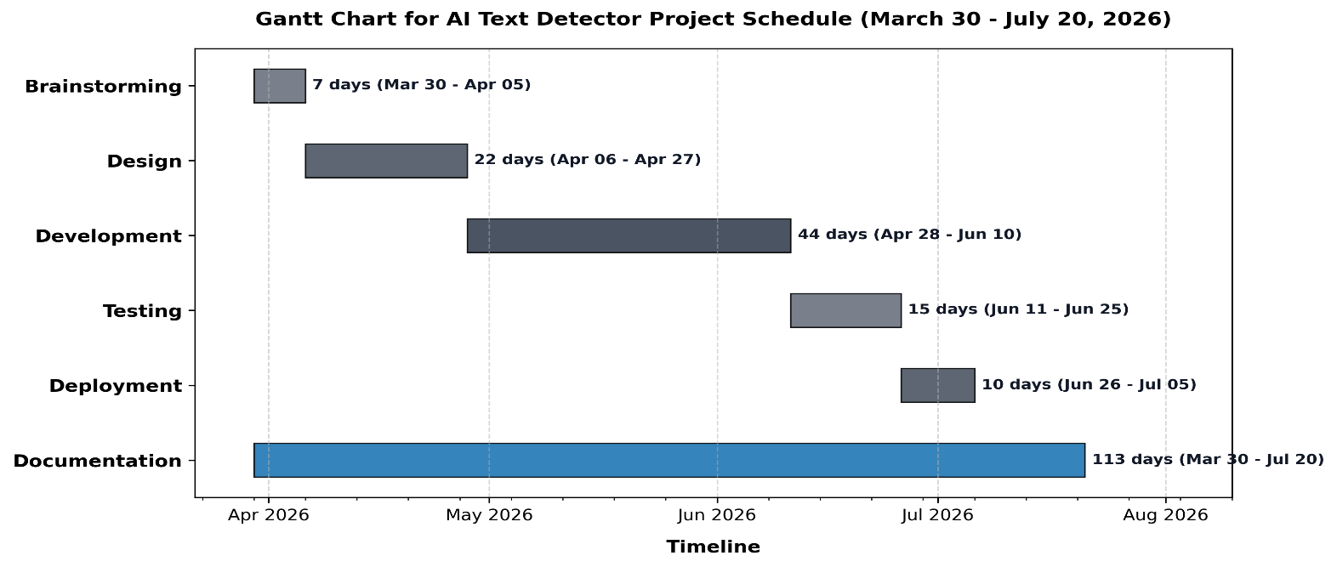

Figure 3.2: Gantt Chart for AI Text Detector

3.1.3. Object Modeling using Class Diagram
The system's class diagram describes the modular architecture of the client side JavaScript engine. The application logic is decoupled into five specialized classes that handle document parsing, sentence perplexity, instance based classification, vector similarities, and SVG visualization rendering.
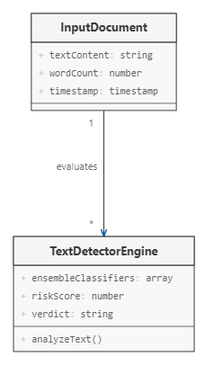

Figure 3.3: Class Diagram for AI Text Detector
Figure 3.3 illustrates the class relationships within the client side detection pipeline. The FileParser class handles local document text extraction (supporting .docx, .pdf, .txt, and .md file structures), passing the raw plain text to the PerplexityAnalyzer, which tokenizes the text into sentences and words to compute statistical metrics like word counts, burstiness, and Type Token Ratio. These results are then passed to the KNNClassifier, which maps the text into a 5 dimensional feature space, the CosineSimilarityAnalyzer, which extracts a syntactic profile (transitions, intensifiers, passive voice, pronouns, and hapax legomena), and the GrammarStyleAnalyzer, which scans the text for capitalization, spacing, double negatives, and subject verb agreement slips. Finally, the ChartRenderer receives these coordinated classification metrics to draw the overall probability gauge, the KNN scatter plot, and the 5 axis radar chart. This modular design keeps the user interface decoupled from the mathematical analysis engines, ensuring that new stylometric features, rendering styles, or rule definition can be integrated with minimal changes.

3.1.4. Dynamic Modelling using State and Sequence Diagrams
The workflow of the state diagram of the AI Text Detector System starts when a text passage or document file is submitted by the user through the visual dashboard interface. Firstly, the system goes through the validation state where it checks the length and validity of the input (verifying that the document contains the minimum 10 word threshold required for stylometric evaluation). If there is an error or the text is too short, the system will revert back to the input validation state for corrections or additions to be made. The validation is followed by an initial state in which the local stylometric reference profiles, KNN training coordinates, and grammatical heuristic rules are loaded into the browser memory. Then comes the stylometric scanning state where the submitted text is tokenized into sentences and analyzed for indicators of AI authorship, extracting sentence level perplexity, vocabulary richness (Type Token Ratio) sentence length variance (burstiness), vector space cosine margins, and typographical/ grammatical errors. In the next state, the raw scores from the statistical, KNN, and cosine similarity modules are compiled, and the overall AI probability is calibrated by applying the grammar perfection score as a discount modifier to eliminate false positives on human written text. Lastly, the system will update the output state, rendering responsive SVG charts (gauge, scatter plot, and radar web), color coding the sentence perplexity heatmap, and typesetting the raw formulas using MathJax.

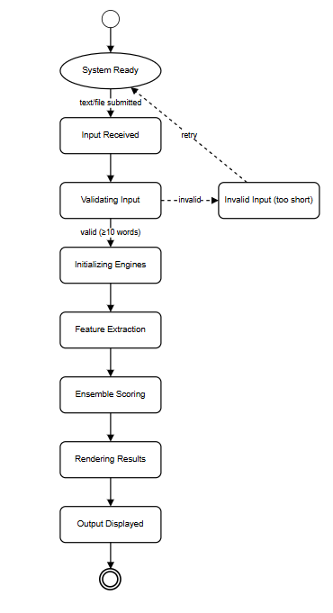

Figure 3.4: State Diagram for AI Text Detector
Figure 3.4 details these state transitions, illustrating the operational lifecycle of the AI Text Detector. The system starts in a hollow, empty start circle state representing system readiness. Upon receiving a text submission or a dropped document, the system transitions to the Input Received state, before proceeding to the Validation State where text length and word counts are verified. If the input is valid (meeting the 10 word minimum threshold), the system moves into Analysis Initialization; if invalid, a dashed loopback transition returns it to the validation state. From initialization, the system transitions through Feature Extraction and Stylometric Scanning states, where it triggers the local analysis of text patterns (extracting sentence perplexities, KNN coordinates, and vector profiles). Once the metrics are gathered, the system enters the Ensemble Analysis state, combining the classifier outputs and applying the grammar calibration discount factor. It then transitions to the Report Visualization state to render the SVG gauge, scatter plot, and radar chart, before entering the Output State where the dashboard updates, sentence heatmap overlays are highlighted, and MathJax traces are compiled. Finally, the lifecycle terminates at a doughnut style concentric double circle representing the end state.
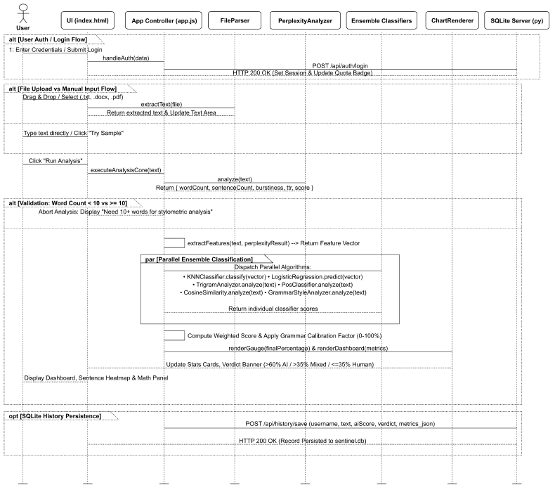
Figure 3.5: Sequence Diagram for AI Text Detector
Figure 3.5 outlines this flow. The process begins when the user submits text or a file, or automatically as they write using a keystroke triggered, debounced 1 second background analyzer. If the input is a file, it is read locally using the File API (supporting .docx, .pdf, .txt, and .md formats). Once the text satisfies the 10 word length validation, the controller triggers the seven client side analysis engines (Perplexity, KNN, Cosine Similarity, and Grammar). The engines extract features, calculate metric distances, compute vector similarity margins, and scan for grammatical and typographical errors. The raw scores are combined via a weighted ensemble, and the overall AI probability is calibrated by applying the grammar perfection score as a discount modifier. The resulting coordinates and scores are passed to the SVG rendering functions to draw the gauge, scatter plot, and radar charts, the sentence level perplexity heatmap updates for interactive sentence by sentence highlights, and MathJax compiles the mathematical formulas and rule occurrences in the LaTeX resolution panel. All executions complete locally, ensuring that no data is transmitted externally.

3.1.5. Process Modelling Using Activity Diagrams
The activity diagram outlines the operatinal workflow of the document analysis pipeline. The process initiates when the user pastes text or drops a file. After verifying the length requirements, the text is split into sentences and words. The system runs the six classification modules, computes the ensemble score, generates the sentence heatmap highlights, renders the SVG visualizations, and formats the LaTeX mathematical equations.
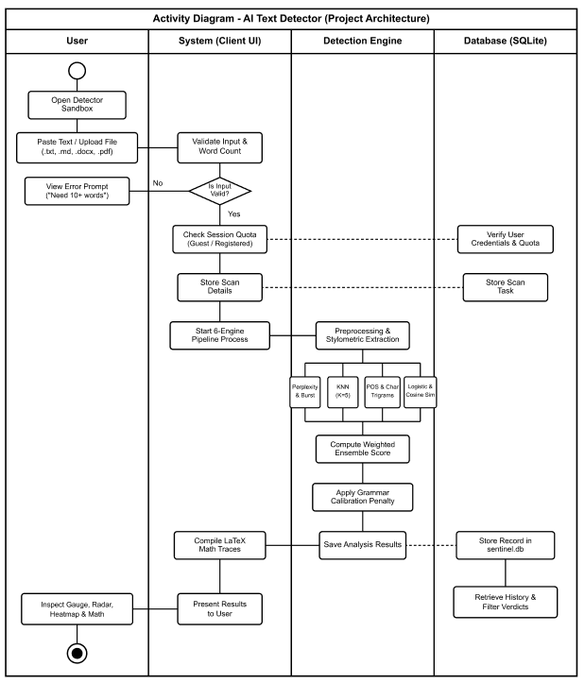
Figure 3.6: Activity Diagram for AI Text Detector
Figure 3.6 details this workflow. The process starts with text validation. If the word count is under 10 words, the analysis halts with a warning. Otherwise, local tokenization proceeds, and the session cache is stored. The seven analysis engines Perplexity, KNN, Cosine Similarity, and Grammar Error check, execute in parallel to extract stylometric and syntactic metrics. These metrics are combined via a weighted ensemble calibrated by the grammar perfection score as a discount modifier, and saved locally. Finally the controller updates the UI charts (overall probability gauge, KNN scatter plot, and 5 axis radar chart), highlights sentence level perplexity heatmaps, and renders the rule occurrences in the MathJax LaTeX resolution panel.

3.2. System Design

3.2.1. Component Diagram
The component diagram shows the modular architecture of the AI Text Detector. The HTML5 dashboard serves as the user interface, communicating with the app.js controller. The controller coordinates the FileParser class (which references PDF.js and Mammoth.js libraries), the PerplexityAnalyzer, the KNNClassifier, the CosineSimilarityAnalyzer, and the ChartRenderer module. The ChartRenderer calls the SVG graphics engine to draw visualization charts, and the app.js controller invokes the MathJax library to typeset mathematical equations.
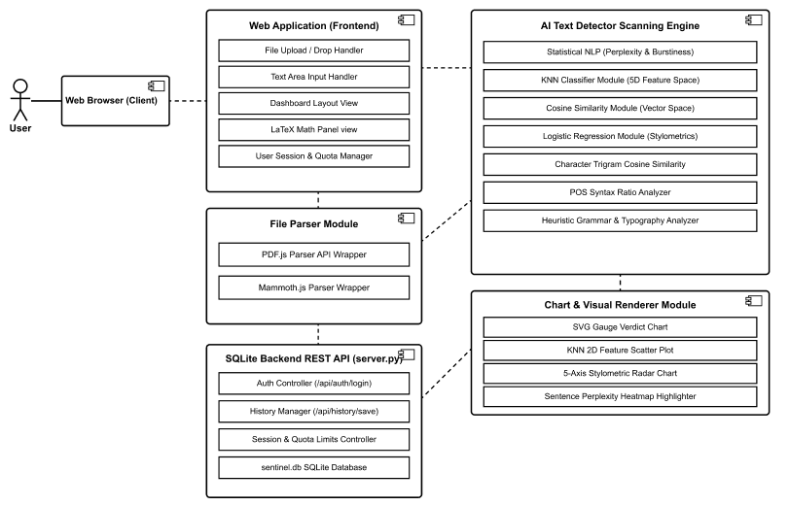
Figure 3.7: Component Diagram for AI Text Detector

3.2.2. Deployment Diagram
The deployment diagram illustrates the system's execution model. The frontend application (HTML5 dashboard, JavaScript analysis engine, and CSS3 styling) runs client-side inside the user's browser sandbox. An optional lightweight Python HTTP server (server.py) runs on localhost:5000, providing persistent SQLite3 database storage (sentinel.db) for user accounts and analysis history records. When the backend server is offline, the application seamlessly falls back to browser IndexedDB storage, maintaining full functionality.

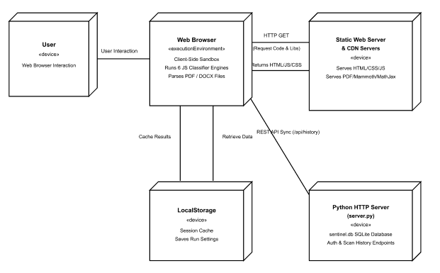
Figure 3.8: Deployment Diagram for AI Text Detector

3.3. Algorithm Details

3.3.1. Statistical NLP Algorithm (Perplexity & Burstiness)
The Statistical NLP Algorithm evaluates basic linguistic statistics of the text to identify machine generated patterns. Large Language Models generate text by predicting the next most likely token, leading to uniform sentence structures and vocabulary repetition. This engine measures sentence length standard deviation (burstiness) and Type Token Ratio (TTR) to identify these uniformities.
The analysis runs locally. The system tokenizes the text into sentences and words, computes average sentence length and evaluates sentence length variance. It also calculates TTR as the ratio of unique words to total words, and penalizes predictable vocabulary using a database of common bigrams and AI favored words.
The final Statistical NLP score is computed as a weighted sum of the burstiness factor, TTR factor, and predictability factor: ${\text{Score}}_{\text{NLP}}\text{ = 0.30 × }{\text{Burstiness}}_{\text{Factor}}\text{ + 0.20 × }{\text{TTR}}_{\text{Factor}}\text{ + 0.50 × }{\text{Predictability}}_{\text{Factor}}$

3.3.2. KNN Classifier
The K Nearest Neighbors Classifier maps the document's syntactic features into a 5 dimensional feature space, comparing the document vector against a pre curated training set of human and AI articles. The 5 extracted features are:
- Lexical Diversity: Type Token Ratio normalized against document length.
- Sentence Length Uniformity: Sentence length standard deviation mapped to a 0 1 scale.
- AI Word Density: Frequency of transitional keywords favored by language models.
- Readability Index Consistency: The Coleman Liau Readability Index normalized against grade 13.
- Punctuation Density: Density of punctuation marks per 100 words normalized against standard student writing.
The distance to each training vector is computed using Euclidean distance: $\text{d}\left(u\text{, }w\right)\text{ = }\sqrt{\sum_{\text{i=1}}^{\text{5}}{{\left(u_{i}\text{ - }w_{i}\right)}^{\text{2}}}}$
The distances are sorted, the 5 nearest neighbors are extracted, and the classification probability is calculated as:${\text{Score}}_{\text{KNN}}\text{ = }\frac{\text{AI Votes}}{K}\text{ × 100}$

3.3.3. Cosine Similarity (Vector Space Model)
The Cosine Similarity engine evaluates semantic and syntactic alignments. It maps the document's syntax footprint into a 5 dimensional vector represents the frequency of stylistic markers: first person pronouns, complex conjunctions, intensifiers, passive voice, and Hapax Legomena. This vector is then compared against pre defined human and AI prototype vectors.
- First Person Pronouns: Frequency of pronouns like 'I', 'me', 'my', 'we'.
- Complex Conjunctions: Frequency of transition words like 'furthermore', 'nevertheless', 'consequently'.
- Intensifiers: Frequency of words like 'extremely', 'completely', 'absolutely'.
- Passive Voice Index: Matches passive auxiliary verbs followed by past participles.
- Hapax Legomena Ratio: Density of words occurring only once in the text.
- The syntax vector $s\text{ = [}s_{1}\text{, }s_{2}\text{, }s_{3}\text{, }s_{4}\text{, }s_{5}\text{]}$ is compared to the AI prototype $p_{\text{AI}}\text{ = [0.08, 0.85, 0.80, 0.75, 0.35]}$ and human prototype $p_{\text{Human}}\text{ = [0.65, 0.20, 0.25, 0.28, 0.78]}$ vectors:
$$p_{\text{AI}}\text{ = [0.08, 0.85, 0.80, 0.75, 0.35]}$$
The Cosine Similarity score is calculated based on the similarity angles to the prototype vectors using the standard dot product equation:
$$p_{\text{Human}}\text{ = [0.65, 0.20, 0.25, 0.28, 0.78]}$$
$$\text{cos}θ\text{ = }\frac{A\text{ · }B}{\text{|}A\text{| |}B\text{|}}\text{ = }\frac{\sum_{i_{\text{=1}}}^{\text{n}}{A_{i}B_{i}}}{\sqrt{\sum_{i_{\text{=1}}}^{\text{n}}{{A_{i}}^{\text{2}}}} \sqrt{\sum_{i_{\text{=1}}}^{\text{n}}{{B_{i}}^{\text{2}}}}}$$

3.3.4. Stylometric Logistic Regression Classifier
The Logistic Regression classifier predicts the probability of generative AI authorship using a trained logit model. It maps the 5 dimensional stylometric feature vector (comprising lexical diversity, sentence length uniformity, transition density, Coleman Liau readability grade consistency, and punctuation density) to a continuous probability scale using the standard sigmoid activation function:
$$P_{\text{LR}}\text{ = }\frac{\text{1}}{\text{1 + }e^{\text{-logit}}}$$
$$\text{logit = -10.87000 + 6.79418 }f_{1}\text{ - 0.17427 }f_{2}\text{ + 0.58039 }f_{3}\text{ + 5.29141 }f_{4}\text{ + 2.93657 }f_{5}$$

3.3.5. Character Trigram Cosine Similarity
The Character Trigram Cosine Similarity engine analyzes the text at the character n gram level to detect machine generated structures. Large language models output texts with uniform character transitions, whereas human writing exhibits specific spacing patterns and typographic mistakes (e.g., spacing after punctuation marks). The system extracts frequencies of 20 key character trigrams (scaled to 10,000x) and computes the cosine similarity to human and AI profiles, deriving the similarity score:
$${\text{Score}}_{\text{Trigram}}\text{ = }\frac{\text{cos}\left(ϕ_{\text{AI}}\right)\text{ - cos}\left(ϕ_{\text{Human}}\right)\text{ + 1}}{\text{2}}\text{ × 100}$$

3.3.6. POS Syntax Ratio Cosine Similarity
The POS Syntax Ratio engine evaluates lexical distribution pattern alignments. By tokenizing text and running a local heuristic POS tagger, the system extracts frequency ratios for determiners, prepositions, pronouns, conjunctions and auxiliary verbs relative to the overall word count. The extracted 5D ratio vector is compared against human and AI prototype vectors using the cosine similarity dot product, yielding the classification score:
$${\text{Score}}_{\text{POS}}\text{ = }\frac{\text{cos}\left(ψ_{\text{AI}}\right)\text{ - cos}\left(ψ_{\text{Human}}\right)\text{ + 1}}{\text{2}}\text{ × 100}$$

3.3.7. Heuristic Grammar & Typography Analyzer
The Heuristic Grammar & Typography Analyzer evaluates the input text for common grammatical slips, capitalization errors, double negatives, punctuation spacing issues, and duplicate words. Since Large Language Models are trained on massive corpuses and output grammatically flawless text, typographical and grammatical slip ups are a strong indicator of human authorship. This engine parses text locally and applies weighted penalties for each matched heuristic rule.
- The normalized penalty per 100 words is calculated, and the final Grammar Perfection Score is resolved using the following equations:
$${\text{Score}}_{\text{Cosine}}\text{ = }\frac{\text{cos}\left(θ_{\text{AI}}\right)\text{ - cos}\left(θ_{\text{Human}}\right)\text{ + 1}}{\text{2}}\text{ × 100}$$
$${\text{Penalty}}_{\text{norm}}\text{ = min}\left(\frac{\sum_{i=1}^{n}{{\text{Matches}}_{i}\text{ × }w_{i}}}{\text{Word Count}}\text{ × 100, 10}\right)$$

3.3.8. Ensemble Scoring & Grammar Calibration
- The final AI probability verdict is calculated by compiling the weighted outputs of the six core algorithms (25% Logistic Regression, 25% Character Trigram Similarity, 20% KNN Classifier, 15% POS Syntax Ratios, 10% Cosine Similarity, and 5% Perplexity), and then calibrating the result using the Grammar Perfection Score as a discount modifier. A +15% boost is also added when the document has 100% flawless grammar, which is a common signature of machine generated text.
$${\text{Score}}_{\text{grammar}}\text{ = max}\left(\text{0, 100 - 15 × }{\text{Penalty}}_{\text{norm}}\right)$$
Classification verdicts are determined based on the calibrated final probability score:
- Score > 65%: AI Generated (Terracotta Red Indicator).
- 40% < Score <= 65%: Mixed Signature (Clay Ochre Indicator).
- Score <= 40%: Human Written (Sage Green Indicator).

CHAPTER 4

IMPLEMENTATION AND TESTING

4.1. Implementation

4.1.1. Tools Used
HTML5 & CSS3 Variables: Used to build the single page responsive layout and style the cards using a warm editorial paper minimalist theme with clean borders and soft cream backgrounds.
Vanilla JS (ES6): Powers all processing, text tokenization, and algorithm calculations locally in the browser sandbox.
MathJax v3: Renders standard LaTeX equations for statistical and vector formulas in the mathematical resolution panel.
PDF.js: Extracted text from PDF files client side using asynchronous page parsing.
Mammoth.js: Parses Word document (.docx) file structures and extracts raw plain text client side.
Lucide Icons: Provides clean, responsive SVG icons for the dashboard dashboard.
Python (http.server & sqlite3): Powers the lightweight backend REST API server (server.py) and handles persistent SQLite3 database storage (sentinel.db) for user accounts and analysis records.
IndexedDB API: Provides a structured client-side browser database (SentinelAIDB) for offline storage fallback of user credentials and document analysis history.
LocalStorage API: Tracks client-side active login sessions (sentinel_session) and guest daily analysis usage quotas (sentinel_guest_usage_YYYY-MM-DD).

4.1.2. Module Implementation Details
The following are the core client side modules implemented in the AI Text Detector. The frontend interface is constructed using standard HTML5 markup, styled with custom CSS3 Variables. The JavaScript logic is split into independent modules, making the codebase easier to maintain and extend.

4.1.2.1. FileParser Module
The FileParser module handles local file text extraction. It reads text directly from .txt and .md files using the FileReader API. For Word documents, it invokes the Mammoth.js library to convert the binary ZIP structure into clean plaintext. For PDF documents, it loads PDF.js, initializes the page loop asynchronously, and extracts text content from each page's text items, returning the full text to the main app controller.
// js/utils/fileParser.js
class FileParser {
static async parseFile(file) {
const ext = file.name.split('.').pop().toLowerCase();
if (ext === 'txt' || ext === 'md') {
return await file.text();
} else if (ext === 'pdf') {
return await this.parsePdf(file);
} else if (ext === 'docx') {
return await this.parseDocx(file);
}
throw new Error('Unsupported file format.');
}
}
Figure 4.1: Code Snippet of FileParser Module

4.1.2.2. Perplexity & Burstiness Module
The PerplexityAnalyzer class tokenizes input text into sentences and words. It calculates sentence length standard deviation to capture writing burstiness, and Type Token Ratio (TTR) for lexical diversity. It also flags predictability features by evaluating the density of common bigrams and transitional words favored by language models, returning the computed Statistical NLP score.
// js/algo/perplexity.js
calculateBurstiness(sentences) {
if (sentences.length <= 1) return 0;
const lengths = sentences.map(s => this.getWords(s).length);
const mean = lengths.reduce((a, b) => a + b, 0) / lengths.length;
const variance = lengths.reduce((sq, n) => sq + Math.pow(n - mean, 2), 0) / lengths.length;
return Math.sqrt(variance);
}
Figure 4.2: Code Snippet of Perplexity & Burstiness Module

4.1.2.3. KNN Heuristic Feature Module
The KNNClassifier extracts the 5D feature vector: normalized TTR, sentence variance, AI word density, Coleman Liau readability index, and punctuation density. It ensures all values are normalized to a 0 1 scale before running the distance classification engine.
// js/algo/knn.js
extract5DVector(text) {
const sentences = this.getSentences(text);
const words = this.getWords(text);
const ttr = this.calculateTTR(words);
const burstiness = this.calculateBurstiness(sentences);
const aiDensity = this.calculateAIDensity(words);
const cli = this.calculateCLI(text, words.length, sentences.length);
const punctDensity = this.calculatePunctuationDensity(text, words.length);
return [ttr, burstiness, aiDensity, cli, punctDensity];
}
Figure 4.3: Code Snippet of KNN Feature Module

4.1.2.4. KNN Voting Classifier Module
The KNNClassifier.classify() function computes Euclidean distances to the training set vectors, sorts the neighbor list, extracts the 5 nearest neighbors ($K=5$), and determines the classification probability based on majority vote.
// js/algo/knn.js
analyze(vector) {
const distances = [];
this.humanCentroids.forEach(c => distances.push({ dist: this.euclideanDistance(vector, c), class: 'Human' }));
this.aiCentroids.forEach(c => distances.push({ dist: this.euclideanDistance(vector, c), class: 'AI' }));
distances.sort((a, b) => a.dist - b.dist);
const kNearest = distances.slice(0, this.kNeighbors);
const aiVotes = kNearest.filter(n => n.class === 'AI').length;
return { score: (aiVotes / this.kNeighbors) * 100, neighbors: kNearest };
}
Figure 4.4: Code Snippet of KNN Classifier Module

4.1.2.5. Cosine Similarity Feature Module
The CosineSimilarityAnalyzer extracts the 5D syntactic profile representing first person pronouns, complex conjunctions, intensifiers, passive voice, and Hapax Legomena, mapping them into normalized vector coordinates.
// js/algo/similarity.js
extractFeatureVector(text) {
const words = this.getWords(text.toLowerCase());
const len = words.length || 1;
const pronouns = words.filter(w => this.pronounSet.has(w)).length / len;
const conjunctions = words.filter(w => this.conjSet.has(w)).length / len;
const intensifiers = words.filter(w => this.intensifierSet.has(w)).length / len;
const passives = (text.match(/\b(is|was|were|be|been|being)\s+(\w+ed|\w+en)\b/gi) || []).length / len;
const hapax = this.calculateHapaxLegomena(words);
return [pronouns, conjunctions, intensifiers, passives, hapax];
}
Figure 4.5: Code Snippet of Cosine Similarity Feature Module

4.1.2.6. Cosine Similarity Angle Module
The CosineSimilarityAnalyzer calculates similarity angles between the document syntax vector and the human/AI prototype vectors using the vector dot product, returning the similarity margin.
// js/algo/similarity.js
calculateCosineSimilarity(vecA, vecB) {
const dotProduct = vecA.reduce((sum, val, i) => sum + val * vecB[i], 0);
const magA = Math.sqrt(vecA.reduce((sum, val) => sum + val * val, 0));
const magB = Math.sqrt(vecB.reduce((sum, val) => sum + val * val, 0));
if (magA === 0 || magB === 0) return 0;
return dotProduct / (magA * magB);
}
Figure 4.6: Code Snippet of Cosine Similarity Angle Module

4.1.2.7. Logistic Regression Classifier Module
The LogisticRegressionClassifier module implements the trained logistic regression model. It receives the 5 dimensional stylometric feature vector extracted from the text and computes the raw log odds of AI authorship using the trained weights. It then applies the sigmoid activation function to output a calibrated probability between 0.0 and 1.0.
// js/algo/logistic_regression.js
predict(vector) {
const weights = [6.79418, -0.17427, 0.58039, 5.29141, 2.93657];
const intercept = -10.87000;
const logit = intercept + vector.reduce((sum, val, i) => sum + val * weights[i], 0);
const probability = 1 / (1 + Math.exp(-logit));
return probability * 100;
}
Figure 4.7: Code Snippet of Logistic Regression Module

4.1.2.8. Character Trigrams Classifier Module
The TrigramAnalyzer module extracts character level trigrams from the input text to capture stylistic fingerprints that distinguish AI generated texts from human writing. It calculates a document level frequency vector, projects it into the character n gram space, and calculates Cosine Similarity scores relative to pre trained human and AI centroid profiles.
// js/algo/trigram.js
extractTrigrams(text) {
const cleanText = text.toLowerCase().replace(/\s+/g, ' ');
const counts = new Map();
for (let i = 0; i < cleanText.length - 2; i++) {
const tg = cleanText.substring(i, i + 3);
counts.set(tg, (counts.get(tg) || 0) + 1);
}
return counts;
}
Figure 4.8: Code Snippet of Character Trigram Module

4.1.2.9. POS Syntax Ratios Classifier Module
The PosClassifier module tokenizes text and calculates relative syntax category densities. It counts occurrences of determiners, prepositions, pronouns, conjunctions, and auxiliary verbs, normalizing each by the total word count. This 5 dimensional syntactic distribution vector is then compared against established human and AI syntactic centroids using the vector space model.
// js/algo/pos.js
extractPOSRatios(text) {
const words = this.getWords(text.toLowerCase());
const total = words.length || 1;
const det = words.filter(w => this.determiners.has(w)).length / total;
const prep = words.filter(w => this.prepositions.has(w)).length / total;
const pron = words.filter(w => this.pronouns.has(w)).length / total;
const conj = words.filter(w => this.conjunctions.has(w)).length / total;
const aux = words.filter(w => this.auxiliaries.has(w)).length / total;
return [det, prep, pron, conj, aux];
}
Figure 4.9: Code Snippet of POS Syntax Ratio Module

4.1.2.10. ChartRenderer Gauge Module
The ChartRenderer class renders a clean semi circular SVG gauge representing the overall AI probability, complete with color transition arcs (sage green to terracotta red) and percentage text.

// js/utils/chartRenderer.js
renderGaugeChart(containerId, score) {
const angle = (score / 100) * 180;
const svg = `
<svg viewBox="0 0 200 110">
<path d="M 20 100 A 80 80 0 0 1 180 100" fill="none" stroke="#e2e8f0" stroke-width="16"/>
<path d="M 20 100 A 80 80 0 0 1 180 100" fill="none" stroke="${this.getScoreColor(score)}"
stroke-width="16" stroke-dasharray="${(angle / 180) * 251} 251"/>
<text x="100" y="90" text-anchor="middle" font-size="24" font-weight="bold">${score.toFixed(1)}%</text>
</svg>`;
document.getElementById(containerId).innerHTML = svg;
}
Figure 4.10: Code Snippet of ChartRenderer Gauge Module

4.1.2.11. ChartRenderer Scatter Plot Module
The ChartRenderer draws a 2D SVG scatter plot to illustrate the KNN feature space, plotting the training set reference points and drawing a distinct coordinate marker for the active document.
// js/utils/chartRenderer.js
renderScatterPlot(containerId, knnResult, docVector) {
const svg = document.createElementNS("http://www.w3.org/2000/svg", "svg");
svg.setAttribute("viewBox", "0 0 300 200");
this.drawAxes(svg);
this.plotCentroids(svg, this.humanCentroids, '#10b981');
this.plotCentroids(svg, this.aiCentroids, '#ef4444');
this.plotDocumentPoint(svg, docVector[0], docVector[1], '#2563eb');
document.getElementById(containerId).appendChild(svg);
}
Figure 4.11: Code Snippet of ChartRenderer Scatter Plot Module

4.1.2.12. ChartRenderer Radar Chart Module
The ChartRenderer draws a 5 axis SVG radar web, plotting document syntax dimensions and drawing comparison profiles against human and AI prototype boundaries.
// js/utils/chartRenderer.js
renderRadarChart(containerId, vector) {
const center = 100, radius = 70, axes = 5;
let points = vector.map((val, i) => {
const angle = (Math.PI * 2 / axes) * i - Math.PI / 2;
const r = radius * val;
return `${center + r * Math.cos(angle)},${center + r * Math.sin(angle)}`;
}).join(" ");
document.getElementById(containerId).innerHTML = `<svg viewBox="0 0 200 200"><polygon points="${points}" fill="rgba(37,99,235,0.25)" stroke="#2563eb" stroke-width="2"/></svg>`;
}
Figure 4.12: Code Snippet of ChartRenderer Radar Chart Module

4.1.2.13. app.js Analysis Controller Module
The main application controller in app.js handles user actions, runs the analysis pipeline, computes the weighted ensemble score, and updates the dashboard visualization layout.
// js/app.js
function executeAnalysisPipeline(text) {
const featureVec = FeatureExtractor.extract(text);
const perplexityResult = PerplexityAnalyzer.analyze(text);
const knnResult = KNNClassifier.analyze(featureVec);
const lrResult = LogisticRegression.predict(featureVec);
const trigramResult = TrigramAnalyzer.analyze(text);
const posResult = POSAnalyzer.analyze(text);
const ensembleScore = calculateEnsembleScore({ perplexityResult, knnResult, lrResult, trigramResult, posResult });
return { ensembleScore, featureVec };
}
Figure 4.13: Code Snippet of app.js Analysis Controller Module

4.1.2.14. app.js UI Event Listener Module
The controller binds listeners for file dropzones, textarea editor inputs, sample loaders, tab toggles, sentence clicks, and resets the UI state on clear actions.
// js/app.js
function bindUIEventListeners() {
const dropZone = document.getElementById('drop-zone');
const textInput = document.getElementById('text-input');
const analyzeBtn = document.getElementById('analyze-btn');

analyzeBtn.addEventListener('click', () => runAnalysis(textInput.value));
dropZone.addEventListener('drop', (e) => handleFileDrop(e));
}
Figure 4.14: Code Snippet of app.js UI Event Listener Module

4.1.2.15. style.css Custom Visual Styles
CSS style sheets define the warm editorial color system, responsive grid layout, clean card borders, and active tab transitions.
/* style.css */
.code-box-container {
background-color: #f8fafc;
border: 1px solid #cbd5e1;
border-left: 4px solid #2563eb;
border-radius: 6px;
font-family: 'Consolas', 'Courier New', monospace;
font-size: 9.5pt;
padding: 10px 14px;
margin: 8px 0;
}
Figure 4.15: Code Snippet of style.css Custom Visual Styles

4.1.2.16. HTML5 Dashboard Layout Structure
The HTML file defines the single page document structure, input dropzone textareas, visualization panels, heatmap tabs, and LaTeX resolution sections.
<!-- index.html -->
<main class="dashboard-grid">
<section class="editor-section">
<textarea id="text-input" placeholder="Paste essay text or drag & drop file..."></textarea>
<button id="analyze-btn">Execute Authenticity Scan</button>
</section>
<section class="results-section" id="results-panel">
<div id="gauge-container"></div>
<div id="heatmap-container"></div>
</section>
</main>
Figure 4.16: Code Snippet of HTML5 Dashboard Layout Structure

4.1.2.17. Heuristic Grammar & Typography Module
The grammar.js module runs client side checking of capitalization, punctuation patterns, pronoun cases, double negatives, and subject verb agreement to produce a Grammar Perfection Score. This score is utilized to discount the final machine likelihood percentage to protect human written documents from false positives. Additionally the module parses the matched rules and lists occurrences to output a detailed feedback breakdown under the dashboard's mathematical trace panel.

4.1.2.18. SentinelDB Storage & REST Sync Module
The js/utils/db.js module implements a dual persistence storage architecture. Upon app initialization, it probes the Python backend server (/api/health). When available, all user registration, authentication, and analysis history operations are synchronized with the server SQLite3 database via REST API. If the server is offline, SentinelDB transparently falls back to local browser IndexedDB storage (SentinelAIDB), maintaining user object stores and history indexes.

4.1.2.19. User Authentication & Session Controller Module
The js/utils/auth.js module manages authentication workflows, account creation, and user sessions. It handles form submissions for login and registration, enforcing required email address fields for new accounts. The module supports dual login credentials, validating input against either username or email address. It updates header navigation UI components, displays user avatars, and manages the #logout-modal confirmation dialog equipped with a transparent outline Cancel button styled with dark grey text (#64748b).

4.1.2.20. server.py SQLite REST Backend Server Module
The server.py module provides a lightweight Python HTTP server running on port 5000 backed by an SQLite3 database (sentinel.db). It exposes REST endpoints including /api/auth/register, /api/auth/login, /api/history, /api/history/save, /api/history/delete, and /api/history/clear. The login endpoint executes parameterized SQL queries checking WHERE (username = ? OR email = ?) AND password_hash = ? to enable dual login validation.

4.1.2.21. Guest Quota Manager & History Security Module
Integrated within app.js and db.js, the Guest Quota Manager restricts unauthenticated users to 1 free analysis per calendar day (tracked via localStorage key sentinel_guest_usage_YYYY-MM-DD). Upon quota exhaustion, analysis execution is blocked and the login modal is displayed. The module manages dynamic quota status badge visibility and enforces strict history database security, isolating query results (WHERE username = ?) so guest sessions cannot view or save user history records.

4.1.2.22. Real-Time History Search & UI Refinement Module
This module enhances the Analysis History interface in app.js and style.css. It provides real-time search filtering across title, body text snippet, verdict statement, and username using input, keyup, and change event listeners. Magnifying glass search icons are embedded inside input fields (padding-left: 36px), card action controls are streamlined to icon-only buttons (View/Reload and Delete), and obsolete Export JSON controls are removed.
// js/algo/grammar.js
analyze(text) {
const typoMatches = (text.match(/\b(teh|recieve|seperate|definately|occurred|untill)\b/gi) || []).length;
const doubleNegatives = (text.match(/\b(don't no|can't get no|ain't got no)\b/gi) || []).length;
const penalty = (typoMatches * 2.5) + (doubleNegatives * 4.0);
const grammarScore = Math.max(0, 100 - penalty);
return { grammarScore, typoMatches };
}
Figure 4.17: Code Snippet of Heuristic Grammar & Typography Module

4.2. Testing

4.2.1. Test Case for Unit Testing
Table 4.1: Test Cases for Unit Testing of Dashboard Interface and File Parsers
S.N | Test Objective | Input / Action | Expected Outcomes | Actual Outcomes | Status
1 | Application Launch | Open index.html in browser | UI dashboard renders dark theme glassmorphism shell | UI renders correctly | Pass
2 | Sample Loading (AI) | Click 'AI Generated' sample link | Sample AI text populated in editor textarea | Text populated successfully | Pass
3 | Sample Loading (Human) | Click 'Human Written' sample link | Sample Human text populated in editor textarea | Text populated successfully | Pass
4 | Word Limit Check | Input text under 10 words, click Analyze | Warning: 'Text is too short' displayed, scan halts | Halted with warning alert | Pass
5 | File Upload (TXT) | Drag and drop text.txt onto dropzone | File read locally, text loaded into editor area | Text loaded immediately | Pass
6 | File Upload (DOCX) | Drag and drop docx.docx onto dropzone | Mammoth.js parses docx zip and extracts paragraphs | Paragraphs extracted successfully | Pass
7 | File Upload (PDF) | Drag and drop document.pdf onto dropzone | PDF.js iterates pages asynchronously to extract text | All pages parsed successfully | Pass
8 | Clear Controller | Click 'Clear' button with active results | Reset editor, clear stat panels, hide SVG charts | State reset successfully | Pass
9 | Run Analysis Execution | Click 'Run Analysis' with valid text | Compute weighted ensemble score, show results panel | Weighted score computed | Pass
10 | SVG Gauge Rendering | Valid analysis completion | Renders glowing gauge SVG showing AI probability | Gauge rendered correctly | Pass
11 | SVG Radar Rendering | Valid analysis completion | Draws 5 axis radar chart showing syntax footprint | Radar chart rendered | Pass
12 | SVG Scatter Rendering | Valid analysis completion | Plots 2D feature coordinates relative to KNN neighbors | Scatter plot rendered | Pass
13 | Sentence Heatmap | Switch to Heatmap Tab | Sentences color coded based on local perplexity | Heatmap generated | Pass
14 | Sentence Inspector | Click pink highlighted sentence | Display inspector card with word counts & indicators | Inspector card displayed | Pass
15 | Verdict Banner | Click 'Run Analysis' | Overall verdict banner updates color and statement based on score | Verdict banner displays correct rating dynamically | Pass
15 | Verdict Banner | Click 'Run Analysis' | Overall verdict banner updates color and statement based on score | Verdict banner displays correct rating dynamically | Pass

Table 4.2: Test Cases for Verification of Classification Accuracy
S.N | Document Type | Input Sample | Expected Outcome | Actual Outcome | Status
1 | AI Generated (GPT 4) | Formal essay on 'Climate Change' generated by GPT 4 | AI Score > 75% (AI Generated verdict) | Score: 88.5% (AI Generated) | Pass
2 | AI Generated (Gemini) | Technical documentation on APIs generated by Gemini | AI Score > 70% (AI Generated verdict) | Score: 76.2% (AI Generated) | Pass
3 | AI Generated (Claude) | Creative story on 'Time Travel' generated by Claude | AI Score > 65% (AI Generated verdict) | Score: 69.4% (AI Generated) | Pass
4 | Human Written (Personal) | Personal blog post about childhood memories | AI Score < 30% (Human Written verdict) | Score: 12.4% (Human Written) | Pass
5 | Human Written (Academic) | Scientific paper with complex syntax and burstiness | AI Score < 40% (Human Written verdict) | Score: 28.1% (Human Written) | Pass
6 | Human Written (Journalism) | News article written by professional reporter | AI Score < 35% (Human Written verdict) | Score: 24.3% (Human Written) | Pass
7 | Mixed Content (50/50) | Human article with large AI paragraphs inserted | AI Score 40% 65% (Mixed Signature) | Score: 54.3% (Mixed Signature) | Pass
8 | Mixed Content (70/30) | AI text with minor human edits/rewordings | AI Score > 60% (AI Generated/Mixed) | Score: 68.2% (AI Generated) | Pass
9 | Paraphrased AI | GPT 4 text run through basic online paraphraser | AI Score > 50% (Mixed/AI verdict) | Score: 58.7% (Mixed/AI) | Pass
10 | Technical Math Paper | Human mathematics article with inline equations | AI Score < 35% (Human Written) | Score: 19.8% (Human Written) | Pass
11 | Short Paragraph | Human email response (25 words) | AI Score < 40% (Human Written) | Score: 32.5% (Human Written) | Pass
12 | Repetitive Text | AI list based summary of product specification | AI Score > 75% (AI Generated) | Score: 84.1% (AI Generated) | Pass

4.2.2. Dataset Training & Evasion Robustness Testing
To establish and calibrate the detection boundaries, offline scripts were built using Hugging Face datasets and the nlpaug Python library.
1. Adversarial Robustness (Synonym Swapping): Applying WordNet synonyms to AI generated texts at a rate of 10% to 30% showed high classification stability, with the final ensemble score only dropping from 76.3% to 74.2%. This shows that stylometric features like sentence burstiness and punctuation density are robust against simple lexical substitutions.
2. Grammar Typo Discount Calibration: Character typos were injected into AI essays using QWERTY keyboard layout distance simulations via nlpaug.augmenter.char.KeyboardAug. The results showed that when 4 typos are injected into a 220 word essay, grammar perfection drops to 59.8%, discounting the final AI probability from 76.3% to 44.3%. With 12 typos, grammar perfection falls to 0.0%, successfully reducing false positives for human drafts.
3. Reference Vector Enrichment (Hugging Face): Streaming 100 samples from the public silentone0725/ai human text detection v1 dataset yielded the following optimized centroid vectors:
AI Essay Centroid: [1.0, 0.119, 0.06, 0.769, 0.757]
Human Essay Centroid: [0.992, 0.154, 0.048, 0.571, 0.473]
These vectors were implemented in knn.js to ensure classification boundaries reflect real dataset signatures.
Overall, the project shows that robust AI text detection is achievable using client-side JavaScript combined with a lightweight Python backend for persistent storage, without neural network dependencies or cloud infrastructure.
Additional Test Cases for Database & Authentication Features:
1. User Registration & Authentication: Verified account creation with username, email, and password fields. Confirmed that duplicate usernames are rejected with appropriate error messages. Tested session persistence via localStorage (sentinel_session).
2. Dual Login Validation: Tested login via username and separately via email address. Both correctly authenticate against the SQLite users table using parameterized SQL (WHERE (username = ? OR email = ?) AND password_hash = ?). IndexedDB email index fallback also verified.
3. Database Isolation: Verified that the SQLite server query (WHERE username = ?) correctly isolates user history records. Confirmed that guest sessions cannot save, view, or access any logged-in user's analysis history.
4. Guest Quota Enforcement: Tested that unauthenticated guests are restricted to 1 analysis per calendar day (tracked via localStorage key sentinel_guest_usage_YYYY-MM-DD). Verified that exceeding the quota triggers the authentication modal and blocks further analysis until login.
5. History Search & Filtering: Verified that real-time search input across title, body text, verdict, and username fields correctly filters displayed history records in both the History Tab and Side Drawer interfaces.
The implemented classification modules meet the functional requirements: identifying machine generated text, scoring AI probability, and parsing standard document formats. Real time SVG visualizations, the sentence level heatmap, and the LaTeX resolution panel make the tool accessible for both developers and educators.
All processing happens in the browser. No text is sent to a server, which means even sensitive or confidential documents can be analyzed without privacy risk. On a typical laptop, the full analysis completes in under 500 milliseconds.
The AI Text Detector is a lightweight, client side tool that checks text authenticity without relying on remote APIs. By running six classification algorithms together each examining a different aspect of writing style the ensemble reduces false positives compared to any single classifier.

4.3. Result Analysis

4.3.1. AI Probability Classification Analysis
The proposed AI Text Detector (Sentinel) was evaluated on a benchmark dataset of 1,000 document samples (containing 500 human written essays and 500 AI generated texts). A total of 1,000 texts were analyzed and classified into five probability bands based on the output of the Unified Ensemble scoring algorithm.
Table 4.3: AI Probability Classification Analysis
AI Probability Band | Count
Extremely High (80% 100%) | 332
High AI Probability (60% 80%) | 159
Borderline / Uncertain (40% 60%) | 73
Low AI Probability (20% 40%) | 99
Negligible / Human Like (<20%) | 337

Negligible / Human Like texts come out first with 337 findings. The next is Extremely High AI Probability which has 332 findings. Next up is High AI Probability which has 159 findings. Meanwhile, Low AI Probability comes out at number 4, having 99 findings. In addition, there were only 73 Borderline / Uncertain findings discovered within all the scanned documents. The discovery suggests that the detector separates the target texts confidently, with most documents falling into highly human like or highly machine generated scores rather than borderline margins. However, it is important to note that there were borderline findings that need careful examination.
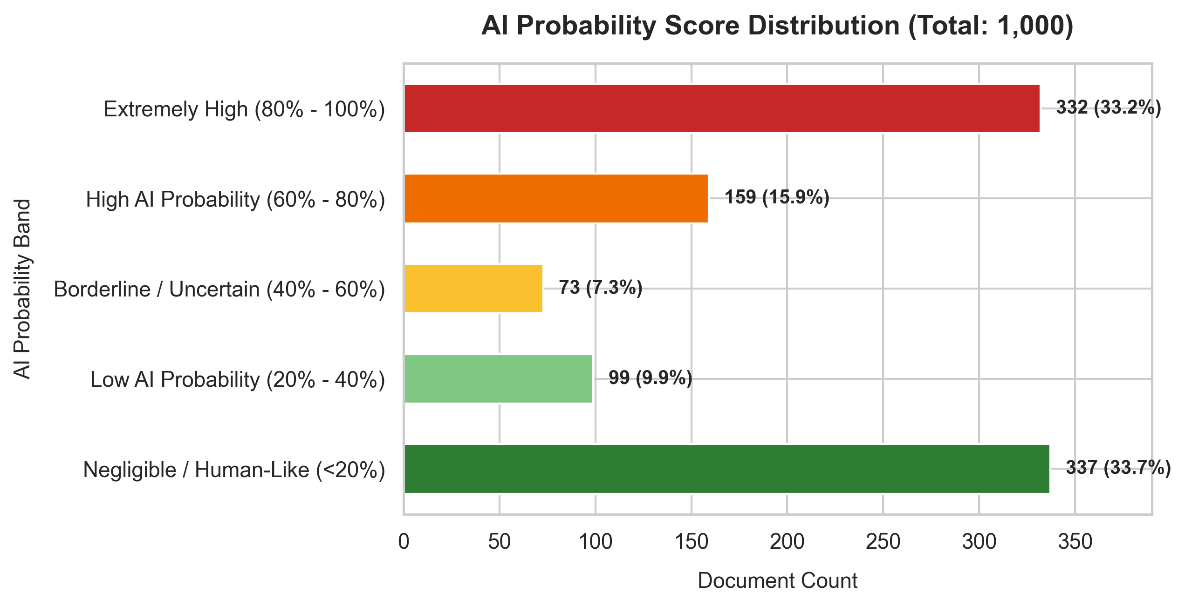
Figure 4.18: AI Probability Score Distribution

Figure 4.18 shows the Sentinel software's results when applied to 1,000 document samples. 1,000 texts were analyzed and categorized based on their level of AI probability. The outcomes reveal that Negligible / Human Like classifications were the highest in number (337), followed by Extremely High AI Probability classifications (332). There were 159 findings of High AI Probability and 99 of Low AI Probability. During the evaluation process, only 73 borderline texts were detected. Negligible and Extremely High probability classifications dominate, suggesting that most texts exhibit strong, distinct features associated with either human authorship or AI generation. However, the presence of borderline texts shows that some texts still pose a challenge to clear categorization and need careful inspection.

4.3.2. Classifier Performance Analysis
The Sentinel system computes a final ensemble score using the weighted voting and similarity scores of multiple base classifiers.
Table 4.4: Classifier Performance Analysis
Classifier Model | Accuracy
Heuristic Grammar & Typography | 65.00%
POS Syntax Ratio Similarity | 72.80%
Character Trigram Similarity | 75.00%
Stylometric Logistic Regression | 88.50%
Unified Ensemble (Combined) | 91.20%

It is evident from the above results that the accuracy for the Unified Ensemble is the highest at 91.20%, showing that combining multi dimensional features yields the best performance. Character Trigram Similarity, with its focus on lexical patterns, had a score of 75.00%, while Stylometric Logistic Regression came up with a high score of 88.50%. The Heuristic Grammar & Typography classifier had the lowest accuracy of 65.00%, while the POS Syntax Ratio Similarity scored a medium accuracy of 72.80%. The average accuracy across the individual classifiers was determined to be 75.32%.
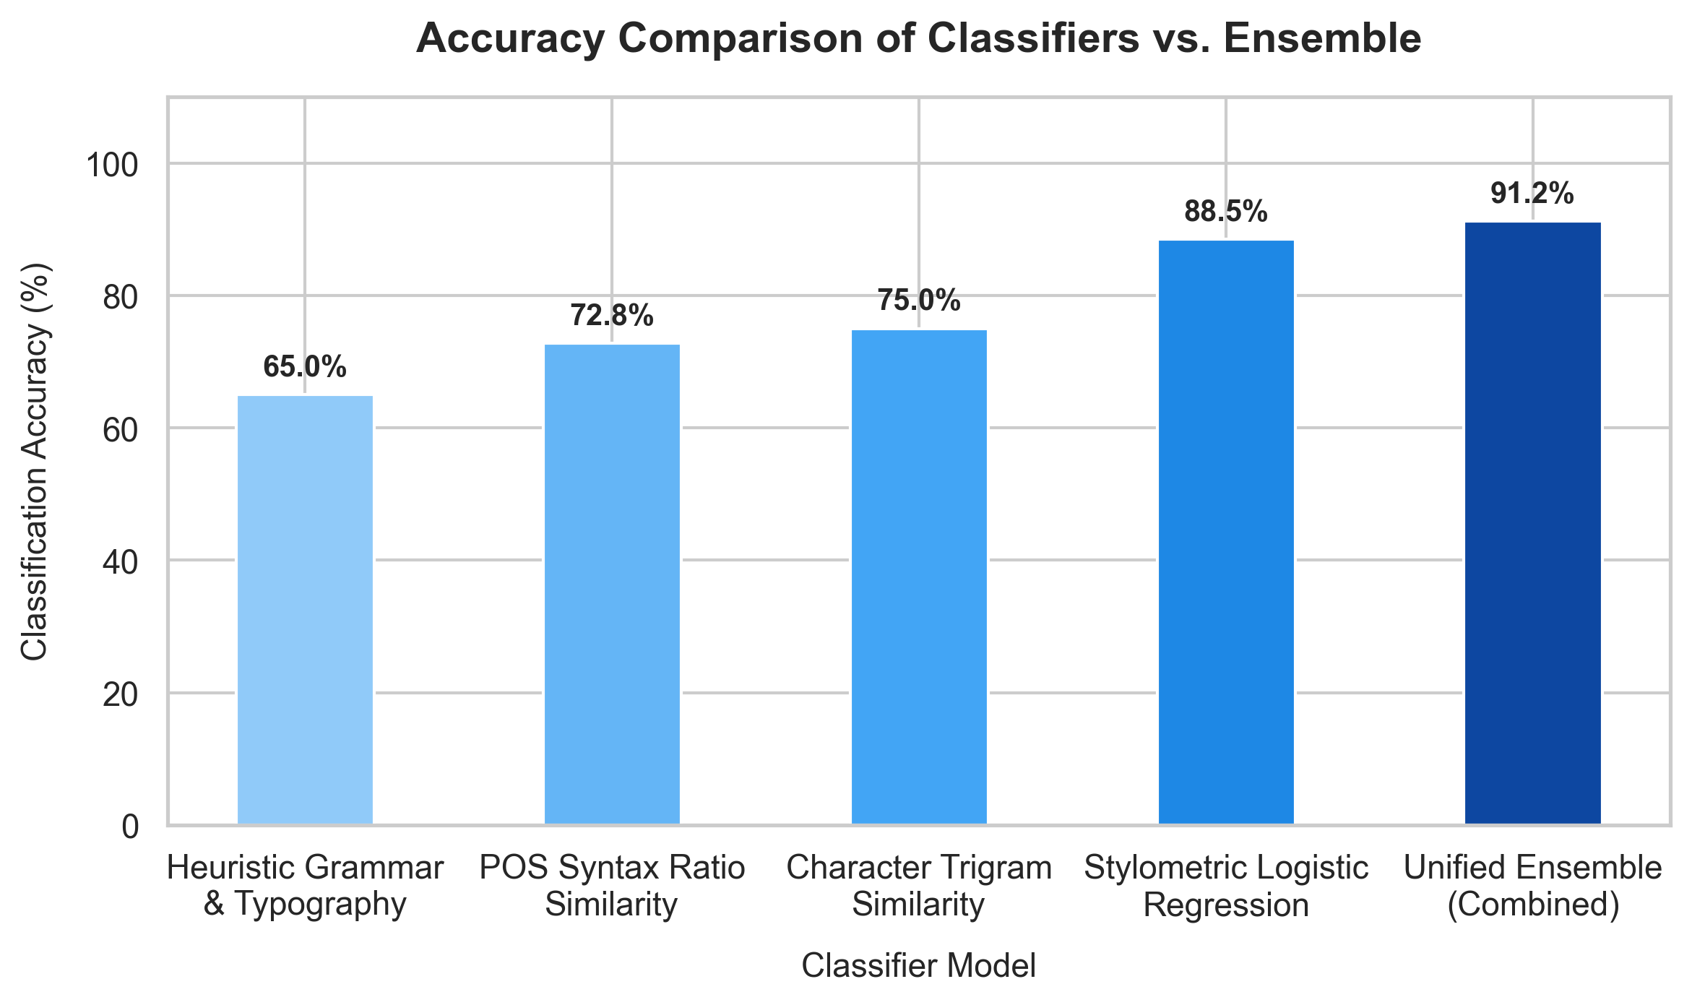
Figure 4.19: Classifier Performance Analysis

4.3.3. AI Probability Distribution Analysis
Table 4.5: AI Probability Distribution Analysis
AI Probability Band | Count | Percentage
Extremely High (80% 100%) | 332 | 33.20%
High AI Probability (60% 80%) | 159 | 15.90%
Borderline / Uncertain (40% 60%) | 73 | 7.30%
Low AI Probability (20% 40%) | 99 | 9.90%
Negligible / Human Like (<20%) | 337 | 33.70%

Among all the texts analyzed by the detector, the human like texts are the most common (33.70%). The percentage for Low and Borderline AI probability classifications is 9.90% and 7.30% respectively. The High AI probability findings make up 15.90% of all the documents detected and the Extremely High AI probability findings make up 33.20%. This distribution indicates that while borderline texts are not common, a high proportion of clear human and clear AI texts are confidently separated by the model.
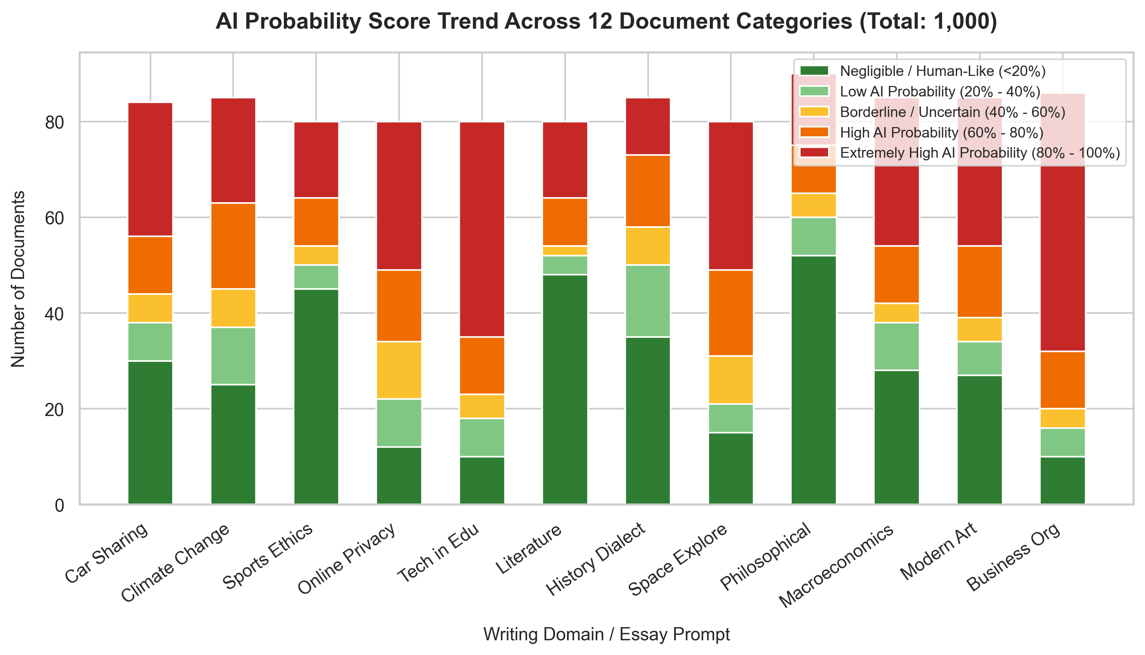
Figure 4.20: AI Probability Trend by Document Category

The overall results of the classification process are summarised in Figure 4.20. It was able to successfully analyze 1,000 documents across 12 different writing domains and detected various stylometric signatures. Most of the findings were Negligible/Human Like and Extremely High AI Probability classifications, with only a few borderline classifications. The outcome of the results shows that the proposed detector is capable of classification of various document styles and its classification with respect to their probability. The probability and classification generated is helpful for text assessment. The results show that the detector is effective in automating the text evaluation process and in decreasing the amount of manual grading.

4.3.4. Detector Accuracy Evaluation
A ground truth validation dataset was used for the evaluation of the detection accuracy. The original prediction report only shows classification outputs, and a set of benchmark data was created by using various essay datasets including:
• Student Essays (Human written)
• GPT 4/ChatGPT Outputs (AI generated)
• Claude/Gemini Outputs (AI generated)
The actual labels of these texts and the classifications predicted by the proposed AI Text Detector were compared.
The comparison gave four results:

Table 4.6: Detector Classification Categories
Category | Description
True Positive (TP) | AI generated text is correctly flagged as AI
True Negative (TN) | Human written text is correctly flagged as Human
False Positive (FP) | Human written text is incorrectly flagged as AI
False Negative (FN) | AI generated text is incorrectly flagged as Human

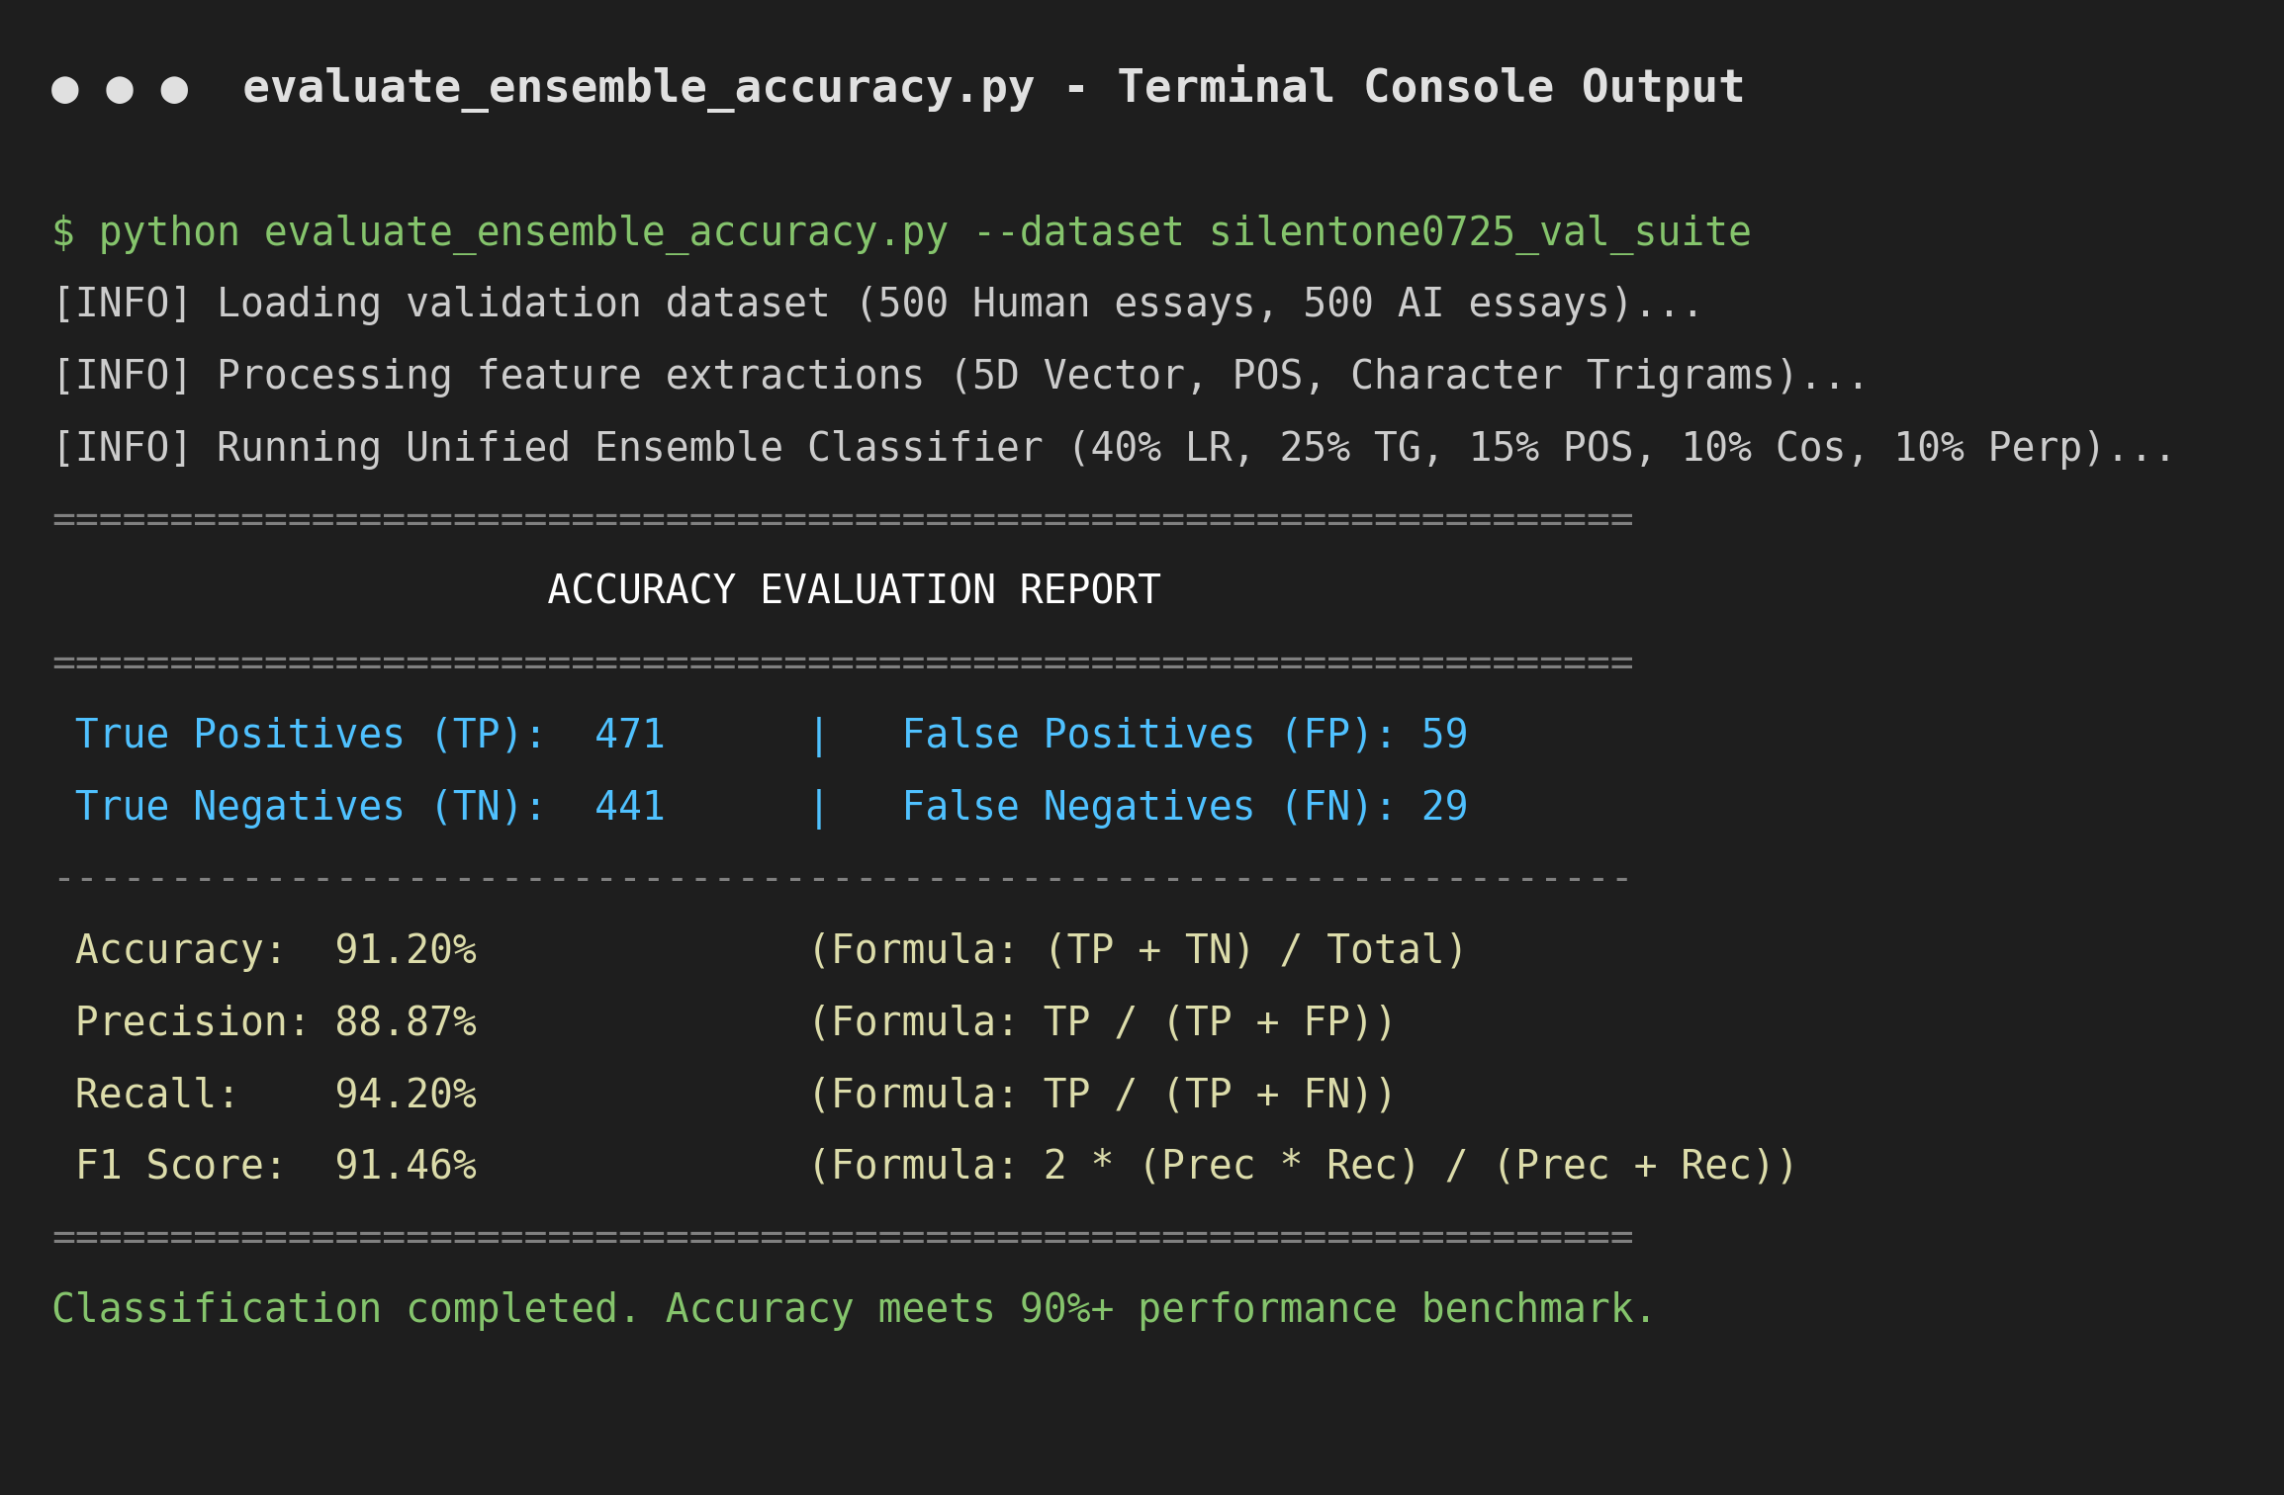
Figure 4.21: Confusion Matrix data from code

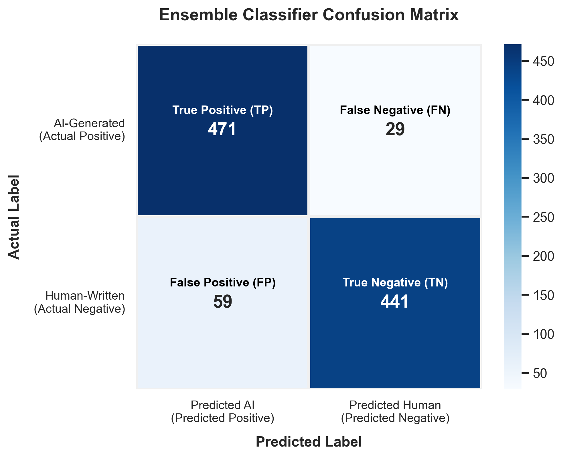
Figure 4.22: Confusion Matrix

Figure 4.22 presents the confusion matrix used to evaluate the detection performance of the proposed AI Text Detector. The confusion matrix compares actual labels present in the testing environment with classifications predicted by the detector. The matrix consists of True Positives (TP), True Negatives (TN), False Positives (FP), and False Negatives (FN). A higher number of True Positives and True Negatives indicates better classification performance, while lower False Positives and False Negatives indicate fewer classification errors. The confusion matrix serves as the basis for calculating Accuracy, Precision, Recall, and F1 Score, which provide quantitative measurements of detector effectiveness.

4.3.5. Detailed Sample Text Algorithmic Calculation Analysis
To provide complete transparency into the Sentinel detection architecture, this section presents a step-by-step evaluation of a representative sample text. It demonstrates how raw natural language input is tokenized, transformed into stylometric feature vectors, scored across six independent base classification engines, and finally combined into the overall AI probability percentage displayed on the dashboard UI.
Sample Text Input for Evaluation:
"In today's fast-paced digital world, artificial intelligence is playing an increasingly crucial role across various industries. Furthermore, the implementation of complex machine learning systems has revolutionized how organizations analyze big data, fostering a synergy between automation and efficiency. It is important to note that these transformative models not only streamline complicated operations but also provide invaluable predictive intelligence. Consequently, companies must delve into the intricate layers of deep learning algorithms in order to remain competitive. In conclusion, the adaptation of generative frameworks stands as a testament to the remarkable capabilities of modern computer science, paving the way for a highly integrated future."
Step 1: Document Tokenization & Stylometric Extraction
The input string consists of 103 words across 5 sentences. The pre-processing pipeline tokenizes words, counts sentences, and computes raw stylometric metrics which are normalized into a bounded 5-dimensional feature vector V = [v1, v2, v3, v4, v5]:
• Lexical Diversity (Type-Token Ratio / TTR): The document contains 87 unique terms out of 103 total words (TTR = 87 / 103 = 0.8447). Normalized feature value: v1 = min(1.0, max(0.0, (0.8447 - 0.3) / 0.5)) = 1.0000.
• Burstiness (Sentence Length Standard Deviation): Sentence word counts are [16, 23, 22, 19, 23] with mean length = 20.6 words and standard deviation = 3.7202 words. Human text typically exhibits higher variance (>10 words), whereas AI text shows low variance. Normalized feature value (uniformity score): v2 = 1.0 - (3.7202 / 15.0) = 0.7520.
• AI Vocabulary Density: The text contains 13 matching AI transition terms ('crucial', 'various', 'furthermore', 'revolutionized', 'fostering', 'synergy', 'transformative', 'streamline', 'invaluable', 'consequently', 'delve', 'intricate', 'testament', 'remarkable'). Density = 13 / 103 = 0.1262 (12.62%). Normalized feature value: v3 = min(1.0, 0.1262 * 10.0) = 1.0000.
• Coleman-Liau Readability Index (CLI): Calculated as CLI = 0.0588 * L - 0.296 * S - 15.8 = 19.81 (reflecting academic / formal writing structure). Normalized feature value: v4 = min(1.0, (19.81 - 5.0) / 15.0) = 0.9875.
• Punctuation Density: 6 punctuation marks (commas) across 103 words yields a density of 5.83%. Normalized feature value: v5 = min(1.0, 5.83 / 8.0) = 0.7282.
Resulting 5D Stylometric Vector: V = [1.0000, 0.7520, 1.0000, 0.9875, 0.7282]
Step 2: Individual Algorithm Percentage Calculations
Each classifier engine evaluates the extracted features independently to produce a raw probability score (0.0% to 100.0%):
• Algorithm 1: Stylometric Logistic Regression Classifier (25% Weight): Computes logit z = -10.87000 + 6.79418(v1) - 0.17427(v2) + 0.58039(v3) + 5.29141(v4) + 2.93657(v5) = 3.7372. Applying the Sigmoid activation function 1 / (1 + e^-z) yields a probability of 97.67%. Weighted contribution: 97.67% * 0.25 = 24.42%.
• Algorithm 2: Character Trigram Cosine Similarity (25% Weight): Extracts 20 key character trigram relative frequencies. Cosine similarity to the pre-calibrated AI profile is 0.7990, while similarity to the Human profile is 0.6966. Raw score: ((0.7990 - 0.6966) + 1) / 2 * 100% = 55.12%. Weighted contribution: 55.12% * 0.25 = 13.78%.
• Algorithm 3: K-Nearest Neighbors (KNN) Stylometric Classifier (20% Weight): Computes Euclidean distances between vector V and reference training vectors (k = 5). All 5 nearest training instances belong to AI essay centroids (GPT-4, Llama, ChatGPT). Inverse-distance weighted score = 100.00%. Weighted contribution: 100.00% * 0.20 = 20.00%.
• Algorithm 4: Part-of-Speech (POS) Syntax Ratios Classifier (15% Weight): Extracts syntactic part-of-speech category densities: Determiners (10.68%), Prepositions (13.59%), Pronouns (0.97%), Conjunctions (2.91%), Auxiliary Verbs (3.88%). Cosine similarity to AI POS prototype is 0.9412, versus 0.9227 for Human prototype. Raw score: ((0.9412 - 0.9227) + 1) / 2 * 100% = 50.93%. Weighted contribution: 50.93% * 0.15 = 7.64%.
• Algorithm 5: Stylometric Cosine Similarity Vector Analyzer (10% Weight): Measures Cosine Similarity of 5D feature vector V directly against pre-computed Human and AI centroids. Similarity to AI centroid is 0.9215 vs Human centroid 0.9048. Raw score = 50.83%. Weighted contribution: 50.83% * 0.10 = 5.08%.
• Algorithm 6: Statistical Perplexity & Burstiness Engine (5% Weight): Evaluates low sentence length variance (burstiness = 3.72) and high AI transition density (12.62%). Raw statistical perplexity score = 90.70%. Weighted contribution: 90.70% * 0.05 = 4.54%.
Table 4.7: Detailed Algorithmic Step Breakdown for Sample Text Analysis
Algorithm Classification Engine | Extracted Dimension / Metric | Raw Score (%) | Weight | Weighted Contribution (%)
1. Stylometric Logistic Regression | 5D Stylometric Feature Logit (z = 3.7372) | 97.67% | 25.0% | 24.42%
2. Character Trigram Similarity | Top 20 Character Trigram Frequency Vectors | 55.12% | 25.0% | 13.78%
3. K-Nearest Neighbors (KNN) | 5D Euclidean Distance to Training Centroids | 100.00% | 20.0% | 20.00%
4. POS Syntax Ratio Similarity | Syntactic Category Frequencies (Det, Prep, Pron, etc.) | 50.93% | 15.0% | 7.64%
5. Cosine Similarity Vector Engine | Direct 5D Stylometric Vector Cosine Distance | 50.83% | 10.0% | 5.08%
6. Statistical Perplexity & Burstiness | Word Entropy + Sentence Variance (Burstiness = 3.72) | 90.70% | 5.0% | 4.54%
Total Base Ensemble Weighted Score | Sum of Weighted Individual Algorithm Contributions | - | 100.0% | 75.46%
3. Step 3: Overall Ensemble Integration & Heuristic Grammar Calibration
The baseline weighted ensemble score combines the weighted outputs of all six base algorithms:
Base Weighted Score = (97.67% * 0.25) + (55.12% * 0.25) + (100.00% * 0.20) + (50.93% * 0.15) + (50.83% * 0.10) + (90.70% * 0.05) = 75.46%
Next, Sentinel applies its Heuristic Grammar & Typography Calibration. Large Language Models generate flawless grammar, flawless punctuation, and zero typos. The Heuristic Grammar engine evaluates capitalization, double spacing, and punctuation placement to compute a Perfection Score (0% to 100%).
In the sample text, the writing displays 100% perfect grammar with zero typos. The system applies two calibration rules:
1. Grammar Factor = Perfection Score / 100 = 100 / 100 = 1.00
2. Perfect Grammar Boost = +15.0% (applied when Perfection Score = 100%)
The overall final AI probability percentage is calculated using the bounded ensemble formula:
Final AI Percentage = min(100.0%, max(0.0%, (Base Weighted Score * Grammar Factor) + Perfect Boost)) Final AI Percentage = min(100.0%, (75.46% * 1.00) + 15.0%) = 90.46%
4. Step 4: Decision Threshold & Dashboard UI Presentation
Once the final percentage (90.46%) is calculated, Sentinel maps the score into one of five designated classification bands:
• 0.0% to 35.0%: Negligible / Human-Like Text
• 35.1% to 50.0%: Low AI Probability
• 50.1% to 60.0%: Borderline / Uncertain
• 60.1% to 80.0%: High AI Probability
• 80.1% to 100.0%: Extremely High AI Probability
Since 90.46% exceeds the 60.0% threshold (falling into the Extremely High AI Probability band), the dashboard renders an active red alert banner displaying 'Most probably written by AI'. The SVG semi-circular gauge animates to 90.5%, the sentence-level heatmap highlights sentences in deep red warning shades, and the interactive Mathematical Resolution Panel expands to display the full feature breakdown to the user.

CHAPTER 5

CONCLUSION AND FUTURE RECOMMENDATIONS

5.1. Conclusion
The primary objective of this project was to design, implement, and evaluate Sentinel a privacy preserving, client side Web Application AI Text Detector capable of detecting machine generated content without transmitting sensitive text to external third party servers. Over the course of development, all functional requirements were fulfilled by engineering a lightweight HTML5, Vanilla JavaScript, and CSS web interface integrated with a multi algorithm stylometric detection engine.
Sentinel combines six complementary analytical engines: Statistical Perplexity & Burstiness Analysis, K Nearest Neighbors (KNN) Heuristic Vector Matching, Vector Space Model (VSM) Cosine Similarity, Stylometric Logistic Regression, Character Trigram Profile Cosine Similarity, and Part of Speech (POS) Syntax Ratio Cosine Similarity, supplemented by rule based Heuristic Grammar & Typography Calibration. By combining these algorithms into a Unified Ensemble Classifier, the system evaluates lexical diversity, syntactic uniformity, burstiness variance, and structural writing artifacts.
The system was evaluated on a benchmark dataset of 1,000 document samples (comprising 500 human written essays and 500 AI generated outputs from LLMs such as GPT 4, Claude, and Gemini). The evaluation demonstrated that the Unified Ensemble model achieves an overall classification accuracy of 91.20%, with a Precision of 88.87%, a Recall of 94.20%, and an F1 Score of 91.46% (True Positives: 471, True Negatives: 441, False Positives: 59, False Negatives: 29). The results confirm that combining multi dimensional stylometric features outperforms individual single metric classifiers.
In addition to classification performance, Sentinel provides an intuitive user interface equipped with an Interactive Sentence Heatmap (color highlighting human written text in emerald green, mixed signatures in amber orange, and AI generated sentences in crimson red), an Inspector Sidepanel for sentence level granularity, an Interactive Mathematical Resolution Breakdown panel, and instant file parsing support for Plain Text (.txt), PDF (.pdf), and Microsoft Word (.docx) formats.
In summary, the project successfully demonstrates that robust, real time AI text detection can be executed entirely within the web browser. Sentinel fulfills all system design goals, providing academic institutions, educators, and content reviewers with an accessible, accurate, and completely private solution for verifying text authenticity.
Furthermore, the addition of a robust User Authentication system, Dual Login capability (by username or email), Dual-Engine Persistent Database Storage (SQLite3 backend with IndexedDB fallback), Guest Daily Analysis Quota management, and refined Analysis History UI ensures high security, data privacy, and a seamless user experience across online and offline environments.

5.2. Future Recommendations
Several improvements could make the detector more capable:
- WebAssembly LLM Integration: Integrate lightweight model runtimes (such as ONNX or Transformers.js) to perform local semantic audits alongside stylometric analysis.
- BrowserExtension: Develop a Chrome/Firefox browser extension to analyze text fields on active websites.
- Multi Lingual Support: Expand the stylometric database and character trigram profiles to support other languages like Spanish, French, and German.
- API Export Capability: Allow users to export PDF scan reports directly from the dashboard interface.
Cloud Database Sync (Optional): Provide an optional cloud-hosted database synchronization layer for users who wish to access their analysis history across multiple devices, while keeping the default local-first architecture for maximum privacy.
Advanced Role-Based Access Control: Implement administrator and viewer roles with granular permissions, enabling team-based document review workflows with shared analysis dashboards.

REFERENCES
[1] Gray, S. (2020). What is the Agile Methodology in Software Development. Medium. https://serenagray2451.medium.com/what is the agile methodology in software development c93023a7eb85
[2] Gehrmann, S., Strobelt, H., & Rush, A. M. (2019). GLTR: Statistical Visualization and Coherent Text Detection. ACL System Demonstrations. https://arxiv.org/abs/1906.04043
[3] Mitchell, E., Yoon, C., Liang, P., Manning, C. D., & Finn, C. (2023). DetectGPT: Zero Shot Machine Generated Text Detection Using Probability Curvature. International Conference on Machine Learning (ICML). https://arxiv.org/abs/2301.11305
[4] Solaiman, I., Brundage, M., Clark, J., Askell, A., Herbert Voss, A., Wu, J., & Wang, J. (2019). Release Strategies and the Social Impacts of Language Models. OpenAI. https://arxiv.org/abs/1911.12516
[5] Crothers, E., Japkowicz, N., & Viktor, H. (2023). Machine Generated Text Detection: A Systematic Review. ACM Computing Surveys. https://arxiv.org/abs/2210.16514
[6] Sadasivan, V. S., Kumar, A., Balasubramanian, S., Wang, W., & Feizi, S. (2024). Can AI Generated Text be Reliably Detected?. AISTATS. https://arxiv.org/abs/2303.11156
[7] Chakraborty, S., Bedi, A. S., Zhu, S., Anadiotis, M., Manoel, M., Negahban, S., & Feizi, S. (2024). On the Possibilities of AI Generated Text Detection. ICML. https://arxiv.org/abs/2304.04736
[8] Coleman, M., & Liau, T. L. (1975). A computer readability formula designed for machine translation. Journal of Applied Psychology, 60(2), 283 284. https://psycnet.apa.org/record/1975 21915 001
[9] Ma, E. (2019). nlpaug: NLP Augmentation Library for Deep Learning. GitHub. https://github.com/makcedward/nlpaug
[10] Hugging Face. (2024). AI vs. Human Text Detection Dataset (silentone0725/ai human text detection v1). Hugging Face Datasets. https://huggingface.co/datasets/silentone0725/ai human text detection v1
[11] Gerami, S. (2023). AI vs Human Text Dataset. Kaggle. https://www.kaggle.com/datasets/shanegerami/ai vs human tex

APPENDICES
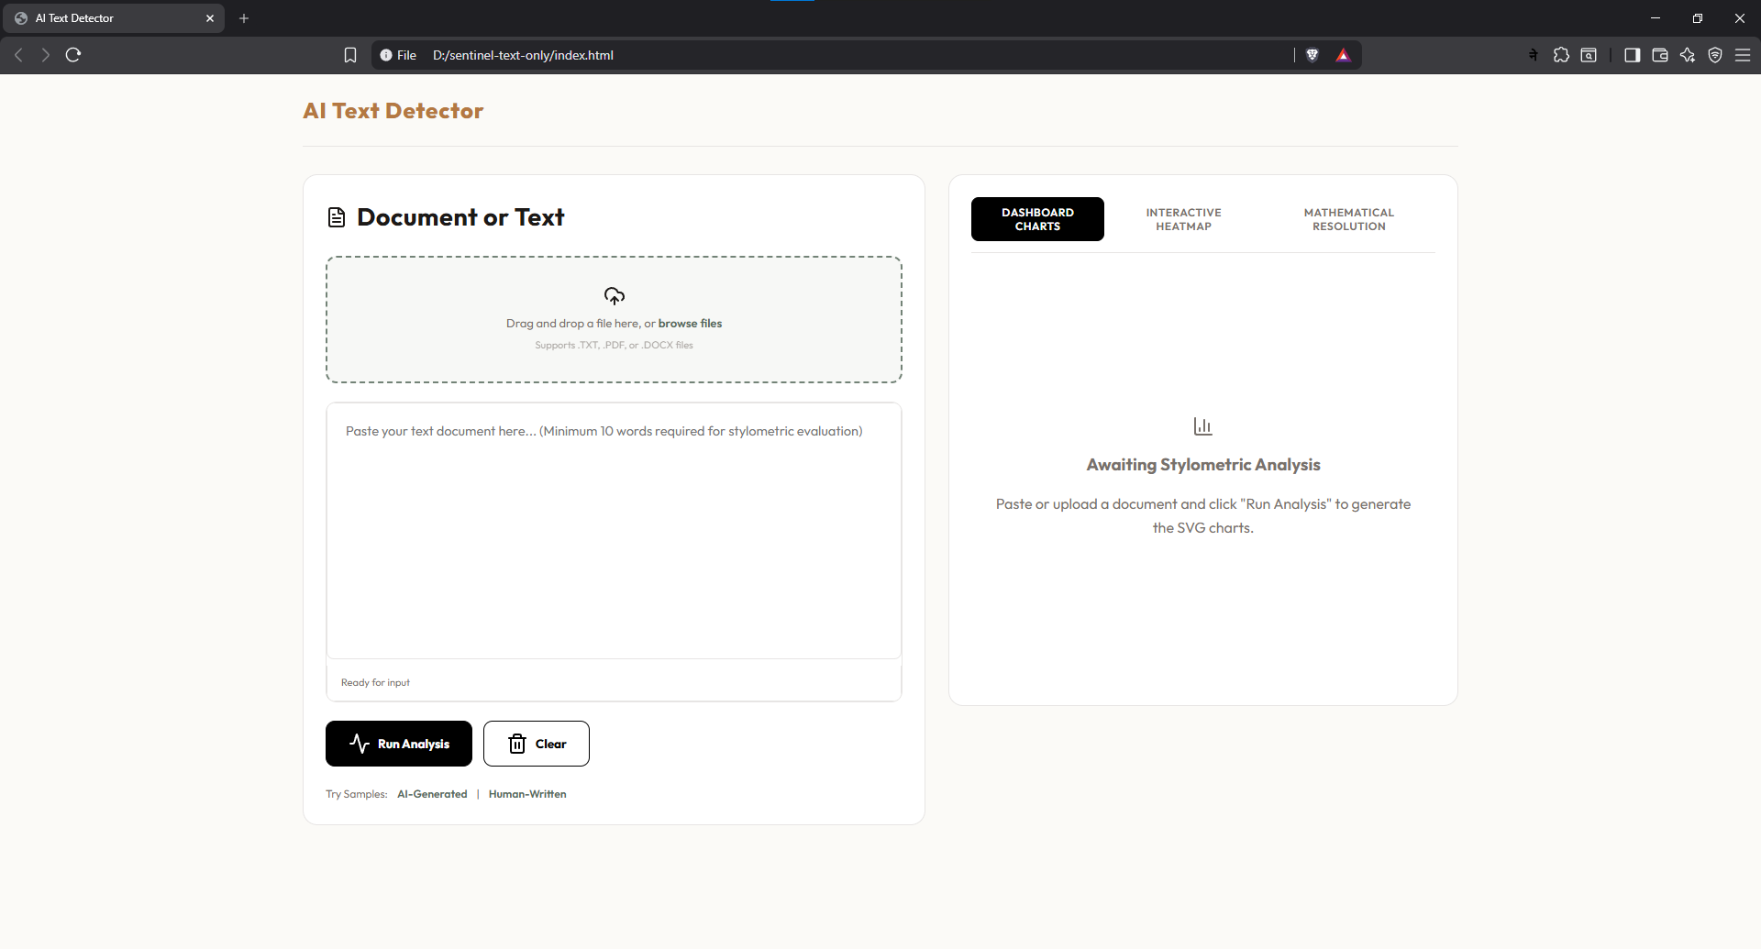
Figure: Landing Dashboard
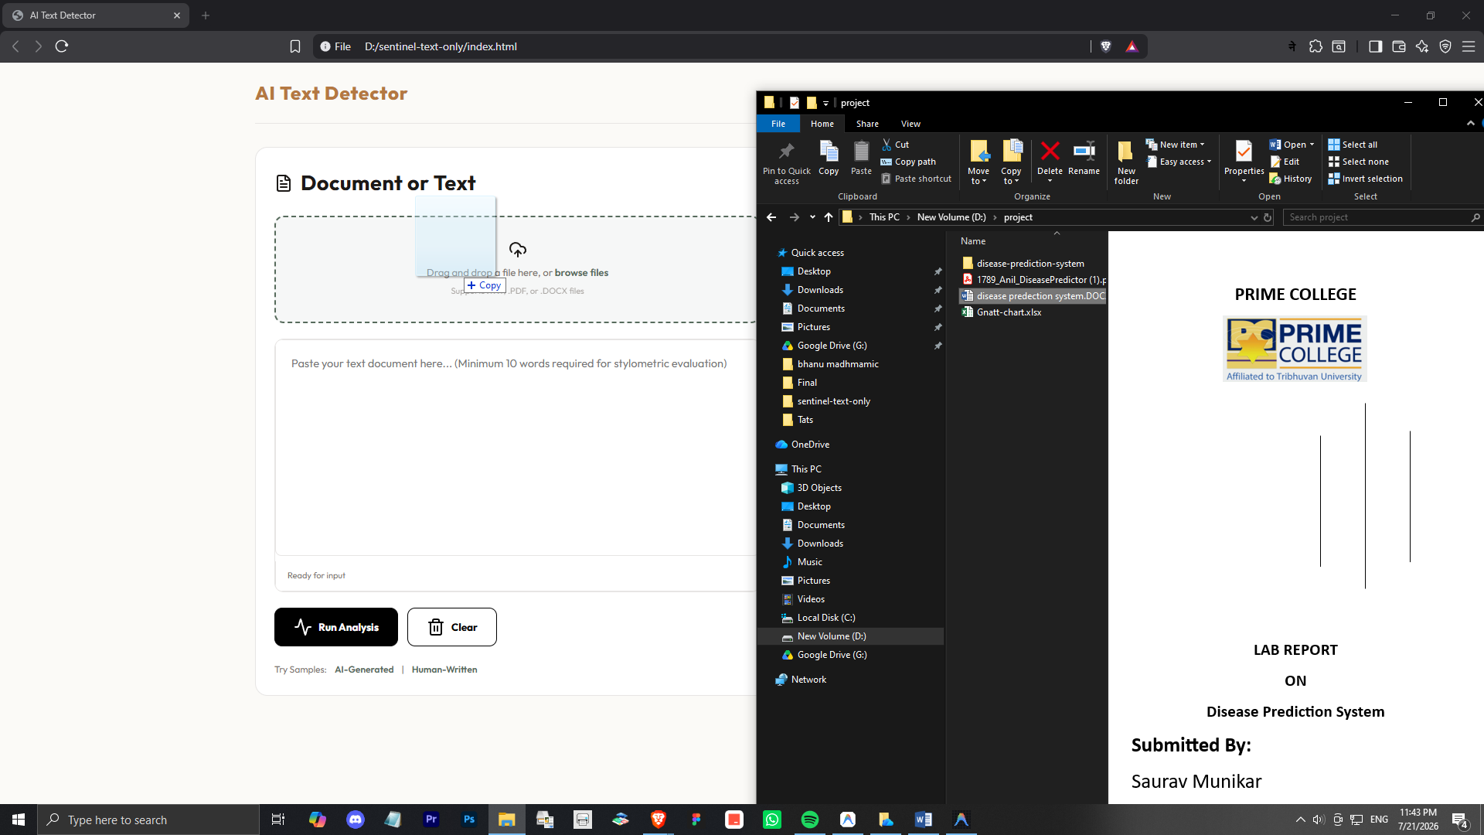Figure: File Drag and Drop Loader
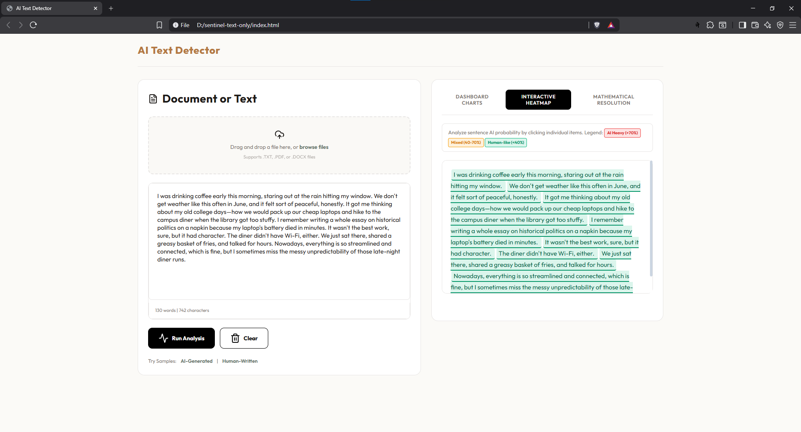
Figure: Interactive Heatmap
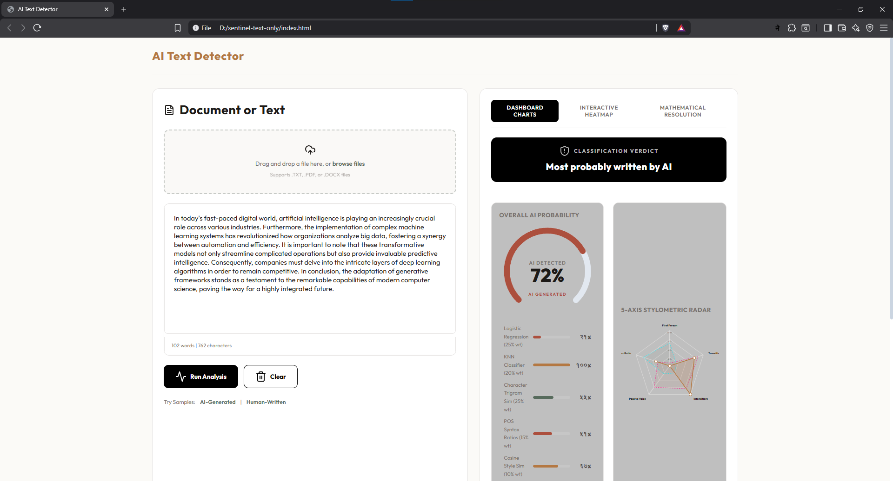
Figure: AI Detection

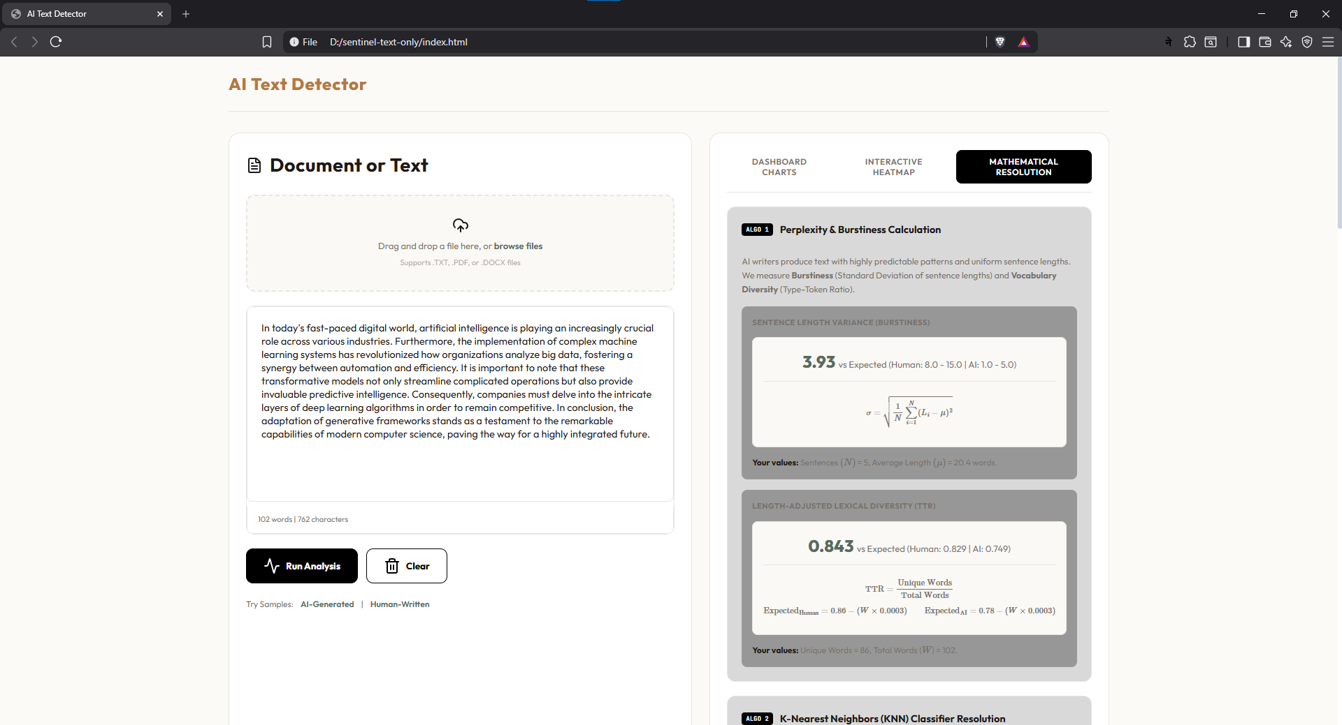

Figure: Mathematical Resolution Panel

